
POSTS AND TELECOMMUNICATIONS INSTITUTE OF TECHNOLOGY
FACULTY OF INFORMATION TECHNOLOGY 1



FINAL REPORT
INFORMATION SYSTEM ANALYSIS AND DESIGN
SUBJECT NO: 02

Lecturer: | Đỗ Thị Bích Ngọc
Class: | E22HTTT
Student’s ID: | B22DCCN845
Student’s name: | Trần Thanh Thúy

Module: Reader registers as a reader card & Reader returns documents

Table of Contents
I. REQUIREMENT 5
1. CONCEPT EXPLORATION 5
2. BUSINESS MODEL 13
A. By natural language 13
B. UML 17
II. ANALYSIS 21
1. SCENARIO 21
A. Module “Reader registers as a reader card” 21
B. Module “Reader returns documents” 22
2. ENTITY CLASS DIAGRAM 24
A. Describe the system within a paragraph 24
B. Extract nouns from paragraph 25
C. Evaluate nouns 25
D. Consider quantitative relationship among classes 26
E. Add object relationship into the diagrams 28
3. CLASS DIAGRAM 29
A. Module “Reader registers as a reader card” 29
B. Module “Reader returns documents” 30
4. STATE DIAGRAM 34
A. Module “Reader registers as a reader card” 34
B. Module “Reader returns documents” 35
5. SEQUENCE DIAGRAM AND COMMUNICATION DIAGRAM 36
A. Module “Reader registers as a reader card” 36
B. Module “Reader returns documents” 38
III. DESIGN 43
1. ENTITY CLASS DESIGN 43
A. Complete classes and attributes 43
B. Convert association relationship to aggregation/ composition 44
C. Add object attributes into classes corresponding to the relationships: aggregation/ composition 44
2. DATABASE DESIGN 46
A. Convert each class into a table 46
B. Make non – object attributes of entity class become attributes of corresponding table 46
C. Make all quantitative relationships among classes become quantitative relationships among tables 47
D. Add key attributes 48
E. Eliminate redundancy attributes 49
3. CLASS DESIGN DIAGRAM 50
A. Module “Reader registers as a reader card” 50
B. Module “Reader returns documents” 51
4. ACTIVITY DIAGRAM 52
A. Module “Reader registers as a reader card” 52
B. Module “Reader returns documents” 53
5. SEQUENCE DIAGRAM 53
A. Module “Reader registers as a reader card” 53
B. Module “Reader returns documents” 54
6. PACKAGE DIAGRAM 60
7. DEPLOYMENT DIAGRAM 61
IV. CODING 61
1. UI 61
A. Module “Reader registers as a reader card” 61
B. Module “Reader returns documents” 63
2. CODING STRUCTURE 69
3. SOURCE CODE 69

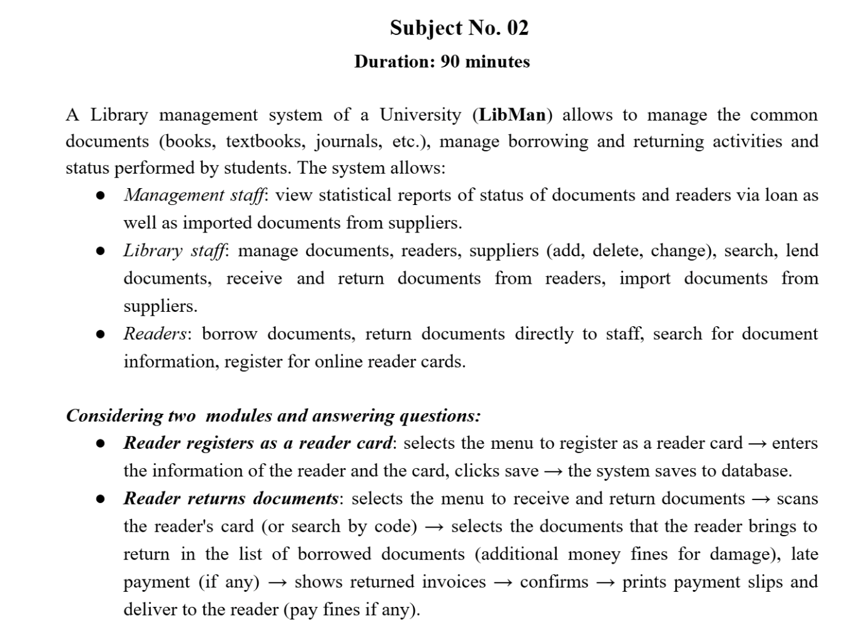

I. REQUIREMENT

1. CONCEPT EXPLORATION
LIBRARY MANAGEMENT SYSTEM GLOSSARY LIST
No | English concept | Vietnamese concept | Meaning
Concepts related to humans
1 | Library member | Nhân viên thư viện | A person who has an account and authority to log in to the library system and perform the functions allowed. For example, a library staff can log in to the system to search for documents, borrow or return books. The information of library staffs is managed within the system. Therefore, a library staff is considered a member of the library system.
2 | Management staff | Nhân viên quản lý | A person who has an account and authority to perform managing functions such as viewing statistical reports of status of documents and readers via loan as well as imported documents from suppliers.
3 | Library staff | Nhân viên thư viện | A person who has an account and authority to manage documents, readers, and suppliers, and are responsible for lending, receiving, and returning documents, and importing new documents into the system.
4 | Supplier | Nhà cung cấp | An organization or individual that provides documents to the library, with their information managed in the system for resource import and updates.
5 | Reader | Bạn đọc | A person who uses the library system to search for documents, borrow and return them, and register for a reader card to access library services.
Concepts related to objects
6 | Document | Tài liệu | An information resource stored and managed in the library system, including books, textbooks, journals, and other materials. Documents can be searched, borrowed, and returned, and their status (available, borrowed, overdue, or damaged) is tracked by the system. Each document record includes a quantity and unique barcodes for individual copies, with each barcode serving as a distinct identifier.
7 | Payment slip | Phiếu thanh toán | A financial document generated by the library system when a reader settles payments, recording details such as fines for overdue or damaged items, deposit deductions, total amount paid, and payment confirmation.
8 | Loan slip | Phiếu mượn | A document generated by the library system when a reader borrows items, recording details such as the borrowed documents, borrowing date, due date, and reader information.
9 | Return slip | Phiếu trả | A document generated by the library system when a reader returns borrowed items, recording details such as returned documents, return date, condition status, and related reader information.
10 | Damage | Hư hỏng | Refers to the physical deterioration or harm of a document, such as torn pages, missing covers, or markings, which may result in fines for the reader.
11 | Statistical report | Báo cáo thống kê | A system-generated summary that provides data analysis on library activities, such as the status of documents, borrowing and returning trends, reader activities, and imported resources from suppliers.
12 | Reader card | Thẻ bạn đọc | An identification card issued by the library that allows readers to access services such as borrowing and returning documents within the system.
13 | Document code | Mã vạch tài liệu | A unique code assigned to each individual copy of a document, used for identification and tracking in the library system during borrowing, returning, and inventory management.
14 | Import invoice | Hóa đơn nhập hàng | A financial document generated by the library system that records the details of documents imported from suppliers, including quantities, unit prices, and the total amount payable.
15 | Fine | Tiền phạt | A monetary penalty imposed on readers for late returns, lost items, or damaged documents, calculated and managed by the library system.
16 | Deposit | Đặt cọc | A financial amount held by the library system when a reader borrows documents, recorded to ensure compensation for overdue, lost, or damaged items, and adjusted or refunded upon return.
Concepts related to activities
17 | Managing suppliers | Quản lý nhà cung cấp | Refers to the process of adding, updating, or deleting supplier information in the library system, as well as recording and tracking documents imported from them.
18 | Managing readers | Quản lý người đọc | Refers to the process of adding, updating, or deleting reader information in the library system, as well as managing their borrowing activities, fines, and reader cards.
19 | Managing documents | Quản lý tài liệu | Refers to the process of adding, updating, or deleting document information in the library system, including tracking their quantity, status, and unique barcodes for individual copies.
20 | Borrowing documents | Mượn tài liệu | Refers to the process in which a reader uses the library system to check out documents, recorded with details such as borrowing date, due date, and the reader’s information.
21 | Returning documents | Trả tài liệu | Refers to the process in which a reader gives back borrowed documents to the library, with the system recording the return date and calculating any fines for late or damaged items.
22 | Document searching | Tìm kiếm tài liệu | Refers to the process in which a user enters keywords such as title, author, or code to find documents in the library system, with the system displaying a list of matching documents and their details.
23 | Registering reader card | Đăng ký thẻ bạn đọc | Refers to the process in which a reader provides required information to the library system to receive a card for accessing library services.
24 | Scanning reader card | Quét thẻ bạn đọc | Refers to the process of using a barcode or card reader to identify a reader in the library system, enabling actions such as borrowing, returning, or verifying reader information.
25 | Confirming return | Xác nhận trả | Refers to the step in which library staff verify the returned documents in the system, finalize the transaction, and record any applicable fines.
26 | Printing slip | In phiếu | Refers to the process of generating and printing a loan, return or payment slip from the library system, providing readers with proof of borrowing, returning, or payment.
27 | Importing document | Nhập khẩu tài liệu | Refers to the process in which library staff add new documents from suppliers into the system, including recording supplier and document information, entering quantity and price, and generating an invoice for payment.
28 | Viewing document statistics | Xem thống kê tài liệu | Refers to the process in which management staff use the system to generate and view reports on document loans within a selected time period, including details of borrowed documents and their corresponding loan slips.
29 | Viewing reader statistics | Xem thống kê người đọc | Refers to the process in which management staff use the system to generate and view reports on readers’ loan activities within a selected time period, including details of borrow times and corresponding loan slips.
30 | View supplier statistics | Xem thống kê nhà cung cấp | Refers to the process in which management staff use the system to generate and view reports on suppliers by imported volume within a selected time period, including details of imported invoices and their corresponding records.
31 | Handling overdue books | Xử lý sách quá hạn | Refers to the process in which library staff manage documents not returned on time, including notifying readers, calculating fines, and updating the loan status in the system.
32 | Paying fines | Nộp phạt | Refers to the process in which readers settle penalties for overdue, lost, or damaged documents, with the system recording the payment and updating the reader’s account status.

2. BUSINESS MODEL

A. By natural language

1. Objective and scope
* Objective: This is a desktop – based application which enables to manage the library management in a university library.
* Scope:
- Type of application: desktop – based application
- Scope of provide: one university library (it could execute on several desktops of the university library but use the same DB)
- User: the library member could use (management staff, system administrator, library staff and reader)
- Provided function:
+ Manage documents, manage readers, manage suppliers
+ Import documents from suppliers
+ Lend documents, return documents, search documents
+ Register reader card
+ View some statistics: document borrowing, reader activities, and supplier imports

2. How do the modules work
* Reader registers as a reader card:
- The reader chooses the “Register reader card” function → The system opens the registration interface with input fields for reader information and a save button.
- The reader enters the required information, each field corresponds to username, password, full name, date of birth, address, phone number, and clicks the save button → The system announces a success alert and then, returns to the reader home UI.
* Reader returns documents:
- A reader approaches the library staff to return documents → Library staff selects the “Return documents” function in the system and asks the reader about the reader card.
- The reader shows his reader card to the library staff → The library staff searches reader information by reader code:
- If the reader card exists in the system database → The system displays the reader information UI with:
  - Reader information (code, name, date of birth, address, phone number)
  - List of currently borrowed documents (with borrow date, due date, status)
- The library staff asks which documents the reader wants to return → The reader presents the documents he wants to return.
- The library staff selects the documents that the reader brings to return in the list of borrowed documents.
- The system automatically calculates if the document is returned late:
- If the return date is after the due date → The system calculates a fine as: Overdue fine = Number of overdue days × Fine rate per day.
- If the return date is on or before the due date → No fine is applied.
- The library staff inspects the returned document:
- If the document is damaged → The system calculates a fine according to the damage severity.
- If the document is not damaged → No fine is applied.
- The system generates a return slip with code, reader code, return date, returned documents (code, title, author, barcode, damage and late fine if any).
- The library staff asks the reader to verify the information on the screen:
- If the reader sees a mistake → The receptionist could correct the information by removing incorrectly processed documents.
- If the reader is satisfied → The library staff clicks the Submit button and complete the transaction.
- The system shows the payment slip with code, return date, reader information, return slip information and total fine if any.
- If there is a fine to be paid → The library staff informs the reader of the fine amount.
- The reader pays fine amount if any → The system prints out the payment slip → The system announces a success alert and then returns to the library staff UI → The library staff informs the success return to the reader and provides return slip → The library staff receives documents from the reader to put them back in the library.

3. Information about objects
* Information related to humans:
- Library member: username, password, role, full name, date of birth, address, phone number.
- Reader: same as library member.
- Staff: same as library member, role.
- Supplier: name, email, phone number, address.
* Information related to facilities:
- Document: Barcode, title, author, category, description, quantity.
- Reader card: Card ID, reader code, issue date, expiry date.
- Fine: Code, name, amount.
* Information related to professional operations:
- Borrow slip: Code, loan date, due date, reader code, list of borrowed documents (each with code, title, author, barcode), status, total number of books borrowed.
- Import invoice: Code, supplier code, date, total amount, list of imported documents (each with code, title, author, barcode, quantity, price).
- Return slip: Code, reader code, return date, list of returned documents (each with code, title, author, barcode, damage), total fine (if any).
* Information related to statistics:
- Document statistics by loan amount: Document name, total loans count, total readers borrowed.
- Reader statistics by loan number: Reader name, total loan number, total borrowed documents.
- Supplier statistics by imported volume: Supplier name, number of imported invoices, total imported volumes.

4. Relationships among objects
- Library – Document: 1 – N
- Reader – Reader card: 1 - 1
- Reader – Borrow slip: 1 – N
- Borrow slip – Document: N – N
- Reader – Return slip: 1 – N
- Return slip – Document: N – N
- Return slip – Damage: N – N
- Supplier – Import invoice: 1 – N
- Import invoice – Document: N - N

B. UML

1. Create actor(s)
- Direct actors:
+ Management staff, administrator (admin), library staff, reader. They are the same type as member of the library (Library member – abstract actor).
- Indirect actor:
+ Supplier. It could kick off the function: importing documents.

2. General use case diagram
* The management staff could use the following functions:
- View statistical reports → View statistics
* The library staff could use the following functions:
- Lend documents → Lend documents
- Receive and return documents from readers → Return documents
- Import documents from suppliers → Import documents
- Manage documents → Manage documents
- Manage readers → Manage readers
- Manage suppliers → Manage suppliers
- Search for document information → Search documents by staff
* The reader could use the following functions:
- Search for document information → Search documents by reader
- Register for online reader cards → Register reader card
* System administrator could use following functions:
- Manage user account by their demand → Manage account
Search documents is the same if it is by library staff or by reader. So we could propose an abstract use case: Search documents.
The obtained general use case diagram is:
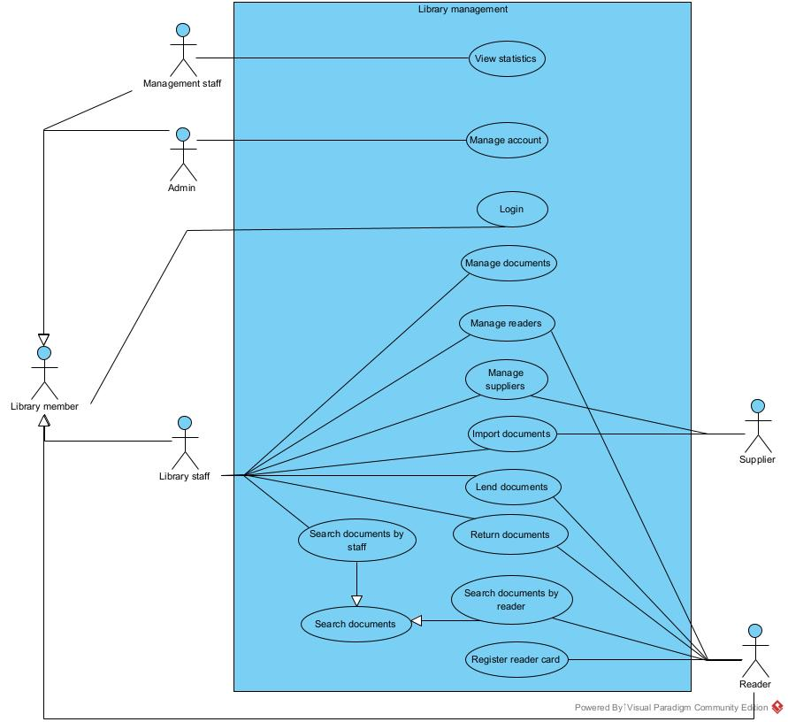
* Description of UC:
- View statistics: this use case enables the management staff to view statistical reports about document borrowing, reader activities, and supplier imports.
- Manage account: this use case enables the administrator to manage the user account by the demand of related user.
- Login: this use case enables the library member to login to the library management system.
- Manage documents: this use case enables the library staff to manage the information about documents.
- Manage readers: this use case enables the library staff to manage the information about readers.
- Manage suppliers: this use case enables the library staff to manage the information about suppliers.
- Import documents: this use case enables the library staff to import documents with the requirement of supplier.
- Lend documents: this use case enables the library staff to lend documents with the requirement of reader.
- Return documents: this use case enables the library staff to receive and return documents with the requirement of reader.
- Search documents: this use case enables the library staff or the reader to search for documents.
- Search documents by staff: this use case enables the library staff to search for documents.
- Search documents by reader: this use case enables the reader to search for documents.
- Register reader card: this use case enables the reader to register a reader card.

3. Detailed use case diagram for module 1: Reader registers as a reader card
The obtained use case is followed:
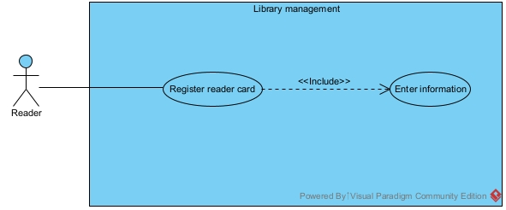
* Use case description:
- Enter information: this use case enables the reader to enter their personal information and card details required for registering a reader card.

4. Detailed use case diagram for module 2: Reader returns documents
The obtained use case is followed:
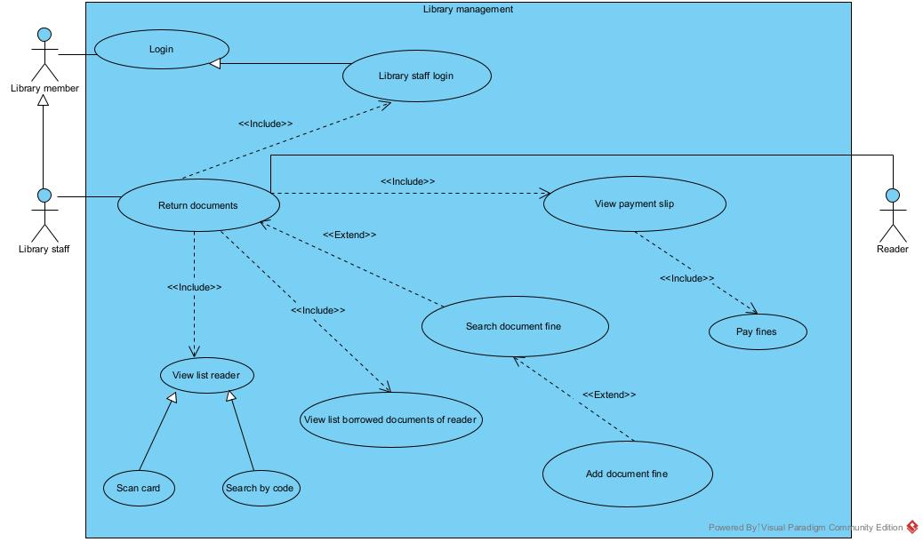
* Use case description:
- Library staff login: this use case enables the library staff to login into the system.
- View list reader: this use case enables the library staff to view the list of readers who are registered in the system. The search could be based on scanning reader card or searching by reader code.
- View list borrowed documents of reader: this use case enables the library staff to view a reader’s currently borrowed documents.
- Search document fine: This use case enables the library staff to search and view the predefined fines related to document damages.
- Add document fine: This use case enables the library staff to add new fines related to document damages.
- View payment slip: this use case enables the library staff to view a reader’s payment slip.
- Pay fines: this use case enables the library staff to record the reader’s fine payment.

II. ANALYSIS

1. SCENARIO

A. Module “Reader registers as a reader card”
Scenario | Register reader card
Actor(s) | Reader
Pre - condition | Reader doesn’t have a reader account
Post - condition | Reader registers as a reader card successfully
Main events | 1. The reader selects registering reader card function from the Home UI.  2. The system shows register reader card UI, there are:  - Input: username, password, full name, date of birth, address, phone number  - Button: save  3. The reader enters username = Trang; password = Trang123@; full name = Le Quynh Trang; date of birth = 02/11/2004; address = 86 Giai Phong, Ha Noi; phone number = 0987654321 and clicks Save.  4. The system shows registering successful message.
Exceptions | 4. The system reports a registering confirmation failure.

B. Module “Reader returns documents”
Scenario | Return documents
Actor(s) | Library staff, reader
Pre - condition | - The library staff has a library staff account.  - The reader brings documents to return.
Post - condition | The reader returns documents and pays fine (if any) successfully.
Main events | 1. A library staff Kien logins with username = Kien, password = Kien2000 into the system to return documents for a reader Trang.  2. The system shows the library staff main UI, which has an option to return documents.  3. The library staff selects returning documents function.  4. The system shows search reader UI, there are:  - Input: reader code  - Button: search  5. The library staff asks the reader for their reader card.  6. The reader provides her card with reader code = 2, name = Trang.  7. The library staff enters “2” into the search field and clicks search.  8. The system displays reader search result UI:  No Code Name Address Phone number  1 2 Trang Ha Noi 0987654321  9. The library staff selects the row with code = 2.  10. The system displays the reader’s borrowed documents list UI:  No Code Barcode Name Type Borrow date Due date Return  1 3 BC003 100 ngay lam chu Java Textbook 05/09/2025 05/10/2025  2 6 BC004 Cuoc phieu luu toi xu so Python Textbook 05/09/2025 05/10/2025  Next  11. The library staff selects the documents that the reader brings to return (may not return all at once).  12. The system shows search fine UI, there are:  - Input: fine name  - Button: search  13. The library staff enters “Torn pages” into the search field and clicks search.  14. The system displays the fine searching UI:  No Name Amount Select  1 Torn Page 20,000 VNĐ  Make payment  15. The library staff selects document fines and clicks button Make payment.  16. The system shows the returned invoice UI:  RETURN SLIP  - Library staff: Tran Duc Kien  No Reader code Name Address Phone number  1 2 Trang Ha Noi 0987654321  No Barcode Name Type Due date Return date Number of days overdue  1 BC003 100 ngay lam chu Java Textbook 05/10/2025 10/09/2025 0  2 BC004 Cuoc phieu luu toi xu so Python Textbook 05/10/2025 10/09/2025 0  No Name Amount Note  1 Torn pages 20,000 VNĐ  - Total fine amount: 20,000 VNĐ  - Total late return fee: 0 VNĐ  - Total: 20,000 VNĐ  Confirm  17. The library staff repeats invoice information to the reader and asks to confirm.  18. The reader agrees and confirms.  19. The library staff clicks on the confirm button.  20. The system shows returning successful message and prints return slip.  21. The library staff delivers return slip to the reader and asks to pay fine (if any).  22. The reader pays fine to the library staff.
Exceptions | 8. There is no reader found.  10. There is no borrowed document found.  20. The system reports a payment confirmation failure.

2. ENTITY CLASS DIAGRAM

A. Describe the system within a paragraph
The system supports to manage the information about the library, the document of the library, the reader borrowed – returned documents of the library and the supplier imported documents in the library. The system enables the management staff to view statistical reports, including document statistics, reader statistics, and supplier statistics. The system enables the system administrator to manage an account for a user of the system when required. The system enables the library staff to manage information about documents, readers, and suppliers; process document borrows and returns for readers; and import documents from suppliers. After each borrowing or returning transaction, the system automatically generates borrow slip or return slip containing complete information about the reader, the documents, the borrow date and due date, and the fines (if any for damage and late return). The system enables the reader to borrow documents directly as well as return documents to library staff, search for document information, and register for a reader card.

B. Extract nouns from paragraph
- Nouns related to humans: management staff, reader, supplier, library staff.
- Nouns related to objects: library, document, borrow slip, return slip, reader card, fine.
- Nouns related to information: system, information, document statistics, reader statistics, supplier statistics, borrow date, due date.

C. Evaluate nouns
* General, abstract, out of scope nouns: system, information, library → eliminate
* Nouns related to humans:
- Library member → LibraryMember (abstract): username, password, full name, date of birth, address, phone number
- Reader → Reader, inherits from LibraryMember
- Staff → Staff, inherits from LibraryMember, role
* Nouns related to objects:
- Document → Document: title, author, category, description
- Borrow slip → BorrowSlip: borrow date, note
- Return slip → ReturnSlip: return date, total fine
- Fine → Fine: name, amount
- Reader card → ReaderCard: issue date, expiry date
* Nouns related to information:
- Document Statistics → DocumentStat: total number of loans, total readers borrowed.
- Reader Statistics → ReaderStat: total documents borrowed, total number of loans.
- Supplier Statistics → SupplierStat: total imported invoices, total imported volumes

D. Consider quantitative relationship among classes
- A Document may have many DocumentCopies according to barcode, a DocumentCopy belongs only to a Document. So, Document – DocumentCopy is 1 - N.
- A Reader may have only one ReaderCard, a ReaderCard belongs only to a Reader. So, Reader – ReaderCard is 1 – 1.
- A Reader may borrow many DocumentCopies, a DocumentCopy may be borrowed by many Readers at different times: so, Reader – DocumentCopy is N - N. So, we could propose a class between them: BorrowSlip.
- A Reader may have many BorrowSlips (in different times). A DocumentCopy may also be borrowed in many BorrowSlips (in different times). Moreover, in a BorrowSlip, the reader may borrow many document copies. So, BorrowSlip – DocumentCopy is still N - N. We need a more class between them: BorrowSlipDetail. This association relationship determines some information: due date, isReturned.
- A Reader may return many DocumentCopies, a DocumentCopy may be returned by many Readers at different times: so, Reader – DocumentCopy is N - N. So, we could propose a class between them: ReturnSlip.
- A Reader may have many ReturnSlips (in different times). A DocumentCopy may also be returned in many ReturnSlips (in different times). Moreover, a ReturnSlip may contain many ReturnSlipDetails. So, ReturnSlip – ReturnSlipDetail is 1 - N.
- A ReturnSlipDetail may record information about many Fines. A Fine may also be appeared in many ReturnSlipDetails. So, ReturnSlipDetail – Fine is N – N. We need a more class between them: FineDetail. This association relationship determines some information: note.
- A ReturnSlipDetail may be associated with only one BorrowSlipDetail. So, ReturnSlipDetail – BorrowSlipDetail is 1 – 1.
- A Staff may create many ReturnSlips for returns. So, Staff – ReturnSlip is 1 – N.
- A Staff may create many Invoices for imports. So, Staff – Invoice is 1 – N.
- A Supplier may have many Invoices for imports. So, Supplier – Invoice is 1 – N.
- An Invoice may have many Document Copies and a DocumentCopy may be included in many Invoices. So, Invoice – DocumentCopy is N – N. We need a more class between them: ImportDocument. This association relationship determines some information: amount, price.
- In the case of statistical class, it inherits from the corresponding entity class: DocumentStat inherits from Document, ReaderStat inherits from Reader, SupplierStat inherits from Supplier.

E. Add object relationship into the diagrams
- Document is a component of DocumentCopy.
- ReaderCard is a component of Reader.
- Reader is a component of BorrowSlip.
- BorrowSlip and DocumentCopy associate to a unique BorrowSlipDetail.
- Reader is a component of ReturnSlip.
- ReturnSlipDetail is a component of ReturnSlip.
- ReturnSlipDetail and Fine associate to a unique FineDetail.
- BorrowSlipDetail is a component of ReturnSlipDetail.
- Staff is a component of ReturnSlip.
- Staff is a component of Invoice.
- Supplier is a component of Invoice.
- Invoice and DocumentCopy associate to a unique ImportDocument.
- Statistical class inherits from the corresponding entity class.


3. CLASS DIAGRAM

A. Module “Reader registers as a reader card”
* The home interface is appeared → need a class: HomeView which has at least:
- An option to choose to register reader card → subRegisterCard
* Choose the option to register reader card → The card register interface is appeared → need a class: RegisterCardView:
- An input text to enter reader username: inUsername
- An input text to enter reader password: inPassword
- An input text to enter reader full name: inFullName
- An input text to enter reader date of birth: inDateOfBirth
- An input text to enter reader address: inAddress
- An input text to enter reader phone number: inPhoneNumber
- A save button: subSave
* The reader chooses to save after completing all the information → The system has to save the reader and the reader card into the DB → need a method:
- Name: addReader()
- Input: an object of Reader
- Output: Boolean
→ Assign this method to the entity class: Reader
* After saving to the DB, the system returns to the HomeView.
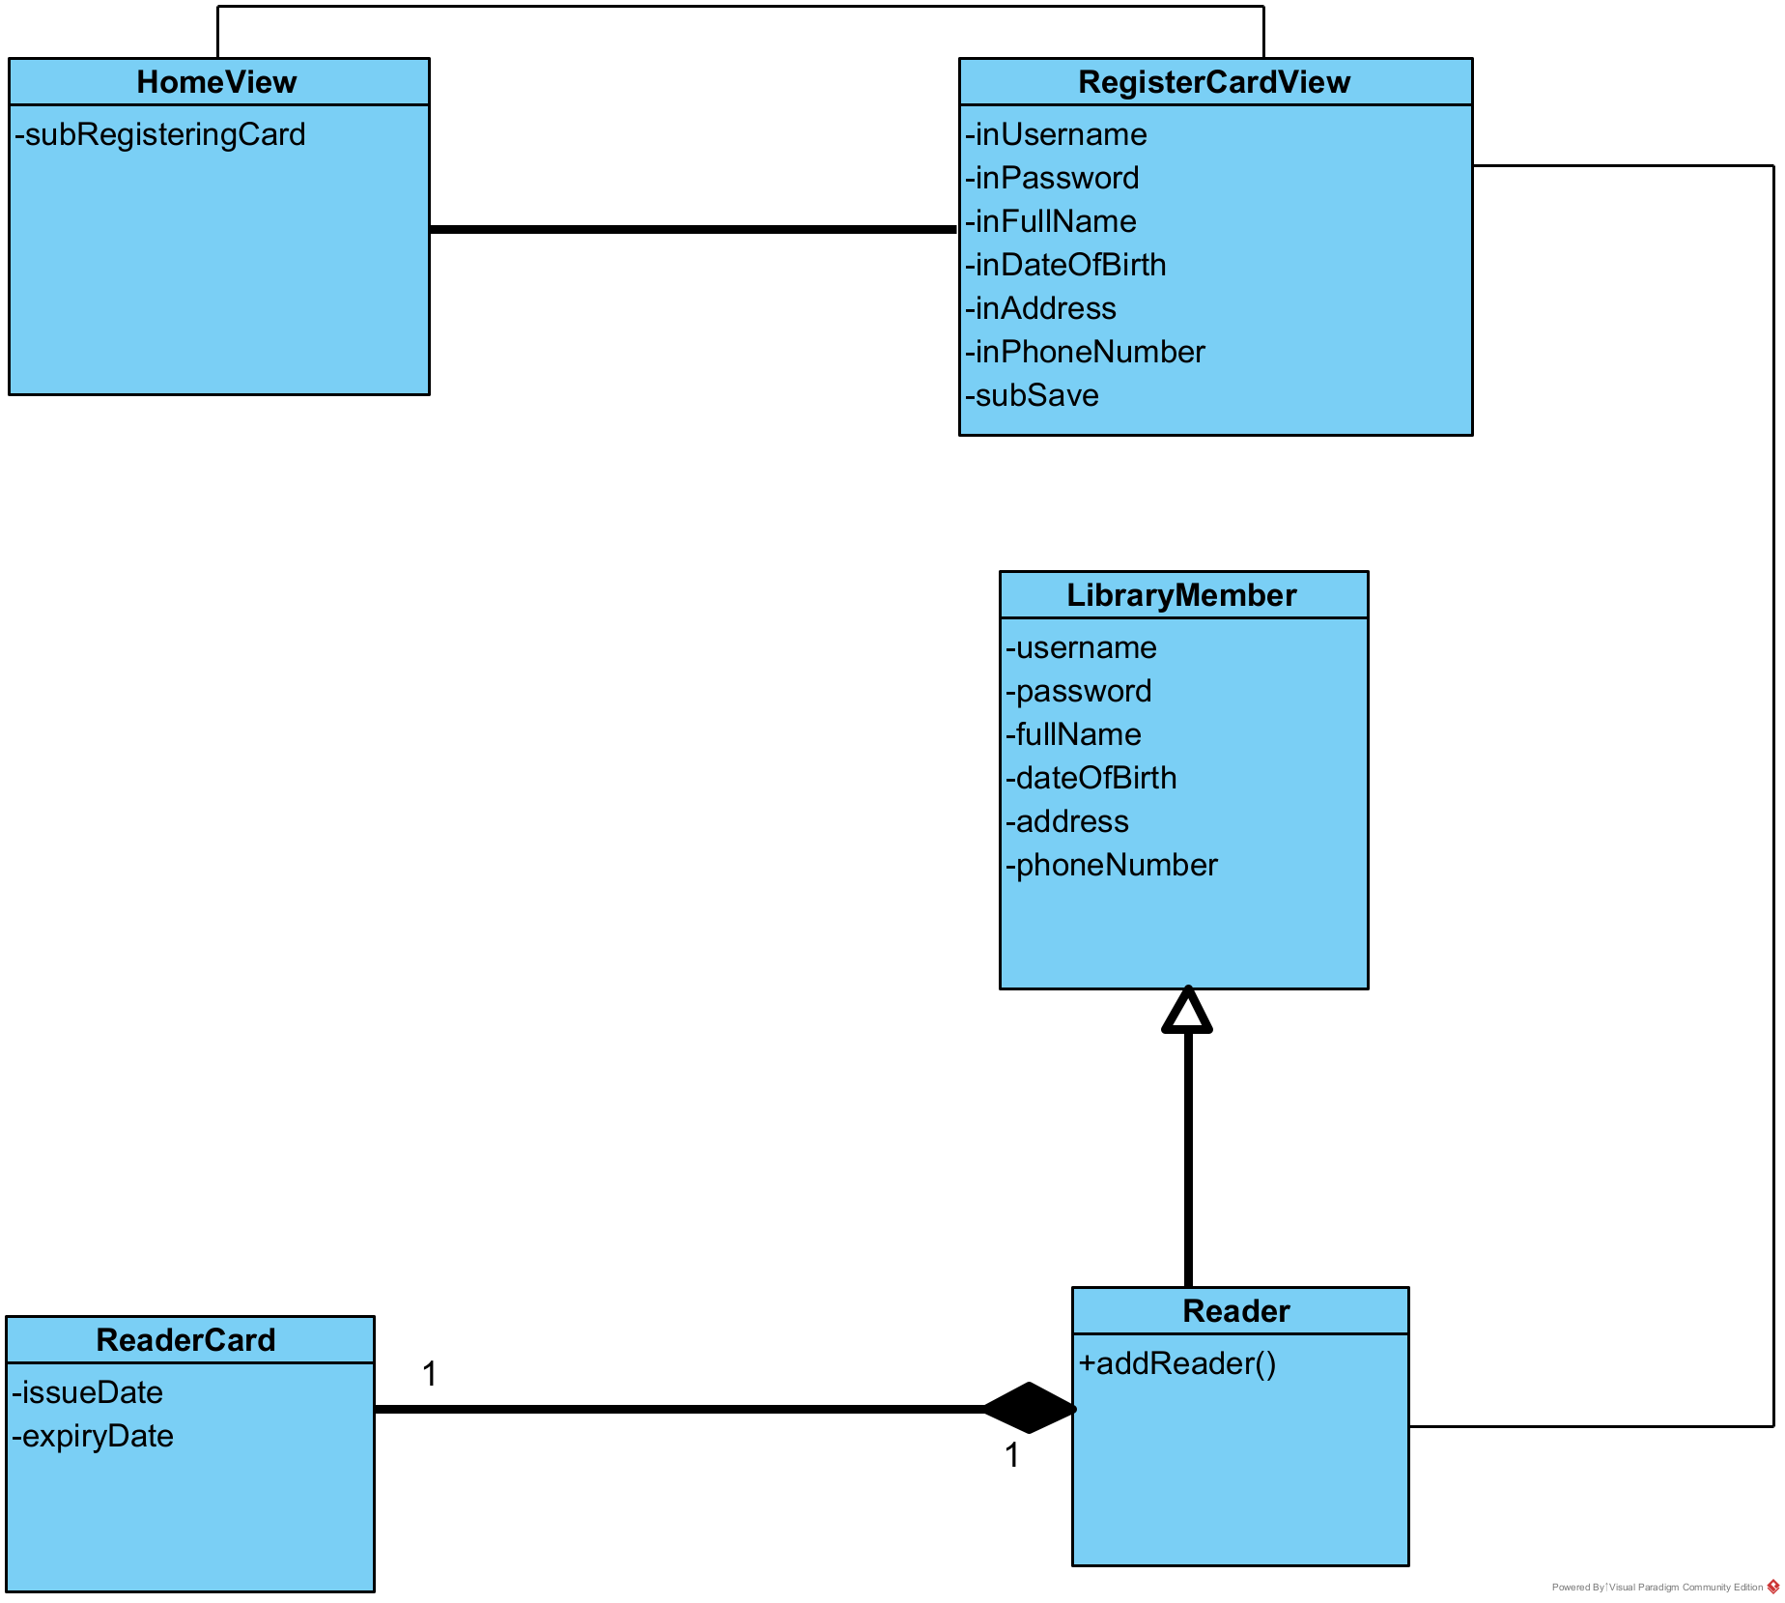

B. Module “Reader returns documents”
* Enter the system → The login interface is appeared → need a class: LoginView
- Input for username → inUsername
- Input for password → inPassword
- A submit to login → subLogin
* Enter the username/password → the system must check if the login is correct → need a method:
- Name: checkLogin()
- Input: username, password (of the class Staff)
- Output: boolean
- Assign to the entity class: Staff
* Once login is successful → The main interface of the library staff is appeared → need a class: StaffHomeView which has at least:
- An option to choose to return documents → subReturning
* The library staff verifies reader information → The interface to search reader is appeared → need a class: SearchReaderView
- Input code to search → inKey
- Button search → subSearch
- A list of results → outsubListReader
* The library staff enter the reader code to search → The system has to search all readers whose code contains the entered keyword → need a method:
- Name: searchReader()
- Input: a keyword
- Output: a list of readers
- Assign this method to the entity class: Reader
* The results are returned to (and displayed on) the SearchReaderView.
* The library staff chooses the correct reader → The interface to view borrowed documents of the reader is appeared → need a class: BorrowedDocumentView
- A list of results → outsubListDocument
- Button next → subNext
* In order to have the data for displaying on the BorrowedDocumentView, the system has to query all borrowed documents related to the reader → need a method:
- Name: getBorrowedDocumentbyReader()
- Input: the reader ID
- Output: a list of BorrowSlip
- Assign this method to the entity class: BorrowSlip
* After clicking the documents the reader brings to return, the library staff clicks Next and search fines related to any damages → need a class: SearchFineView
- Input fine name to search → inKey
- Button search → subSearch
- A list of results → outsubListFine
- A list of fine detail → outsubListFineDetail
- A button to pay fines → subMakePayment
* The library staff enters the fine to search → The system has to search all fines whose name contains the entered keyword → need a method:
- Name: searchFine()
- Input: a keyword
- Output: a list of fines
- Assign this method to the entity class: Fine
* The return slip interface is shown after clicking Make Payment → need a class: ConfirmReturnView
- Display staff name → outStaffName
- Display all information about customer → outCustomer
- Display all information about return slip detail → outReturnSlipDetail
- Display all information about fine detail → outFineDetail
- A confirm button → subConfirm
* The library staff chooses to confirm after having the aggregation from the reader → The system has to save the reader return slip into the DB → need a method:
- Name: addReturnSlip()
- Input: an object of ReturnSlip
- Output: boolean
→ Assign this method to the entity class: ReturnSlip
* The library staff adds return slip successfully → The system has to update the status of borrow slip details into the DB → need a method:
- Name: updateStatus()
- Input: a list of BorrowSlipDetail
- Output: boolean
→ Assign this method to the entity class: BorrowSlipDetail
* After saving to the DB, the system returns to the StaffHomeView.
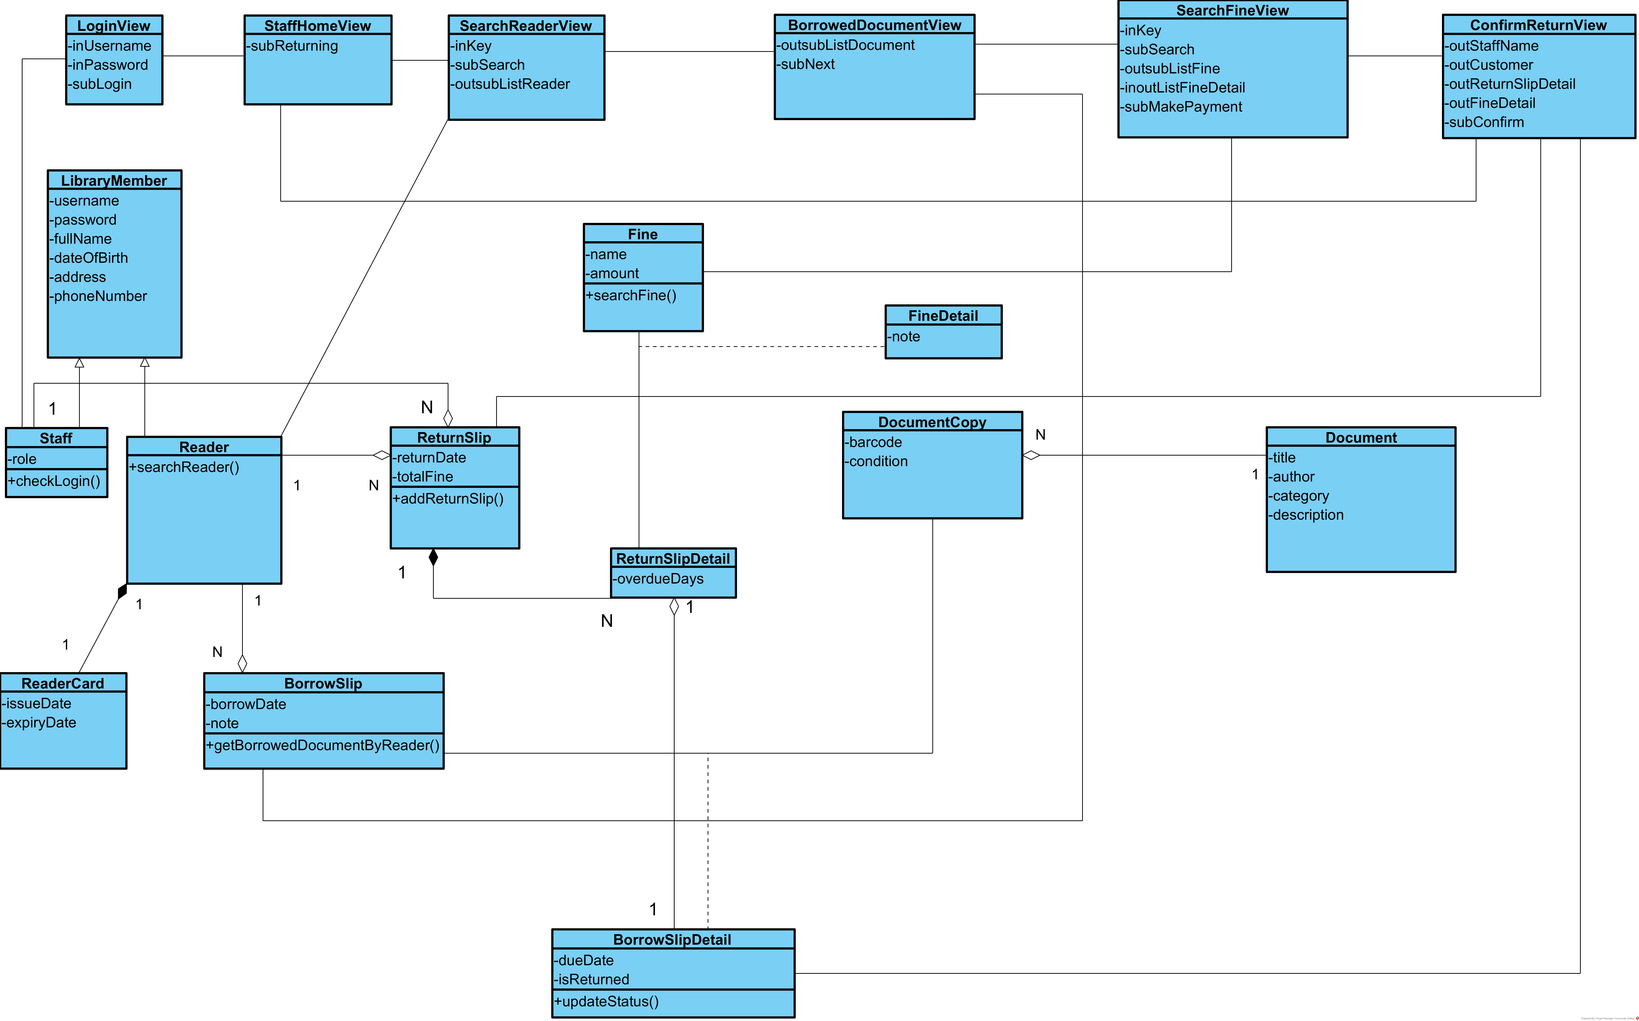

4. STATE DIAGRAM

A. Module “Reader registers as a reader card”
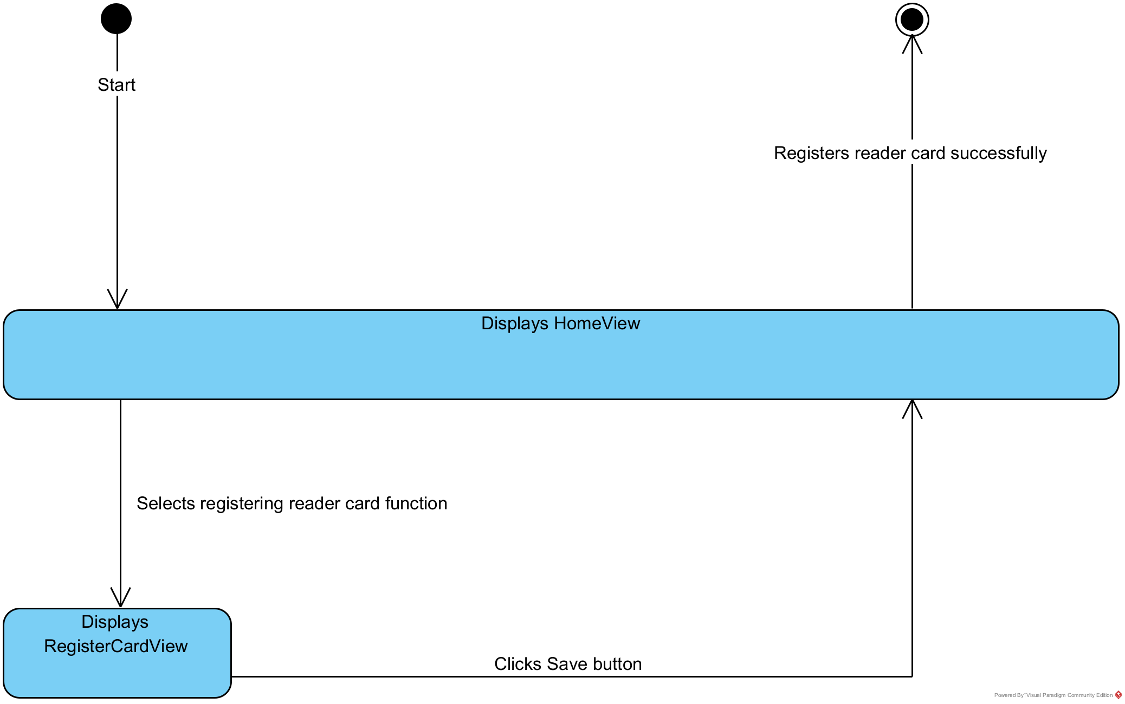
- On the home interface, the system switches to the reader card register interface when the card register function is chosen.
- On the card register interface, after entering the existent information of the reader card and clicks Save button, the system stores the reader card and finishes.

B. Module “Reader returns documents”
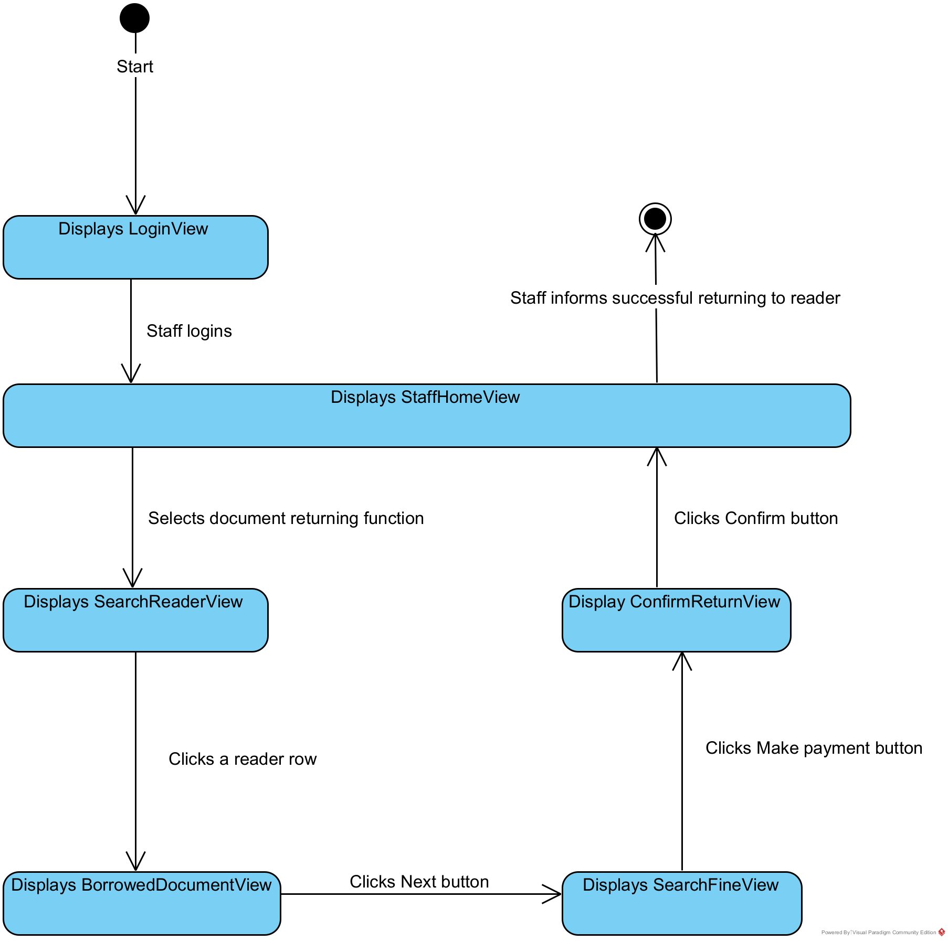
- On the login interface, when the library staff enters valid credentials and clicks “Login”, the system switches to the library staff home interface.
- On the staff home interface, the system switches to the search reader interface when the document returning function is chosen.
- On the search reader interface, when the staff selects a reader row whose code contains the entered keyword, the system switches to the borrowed document interface.
- On the borrowed document interface, when the staff selects all returned documents and clicks “Next” button, the system switches to the search fine interface.
- On the search fine interface, when the staff clicks the “Make payment” button after selecting fines, the system switches to the confirm return interface.
- On the confirm return interface, when the staff clicks the “Confirm” button, the system informs successful returning and finishes.

5. SEQUENCE DIAGRAM AND COMMUNICATION DIAGRAM

A. Module “Reader registers as a reader card”
* Scenario version 2:
1. The reader chooses the option to register reader card on the interface
HomeView.
2. The class HomeView calls the class RegisterCardView.
3. The class RegisterCardView displays the existent information of the reader card to the reader.
4. The reader enters all attributes and clicks on Save button.
5. The class RegisterCardView calls the class Reader to process.
6. The class Reader calls the method addReader().
7. The class Reader returns to the class RegisterCardView.
8. The class RegisterCardView displays a successful message to the reader.
9. The reader clicks on the OK button of the message.
10. The class RegisterCardView calls the class ReaderHomeView.
11. The class ReaderHomeView displays itself to the reader.
* Communication diagram:
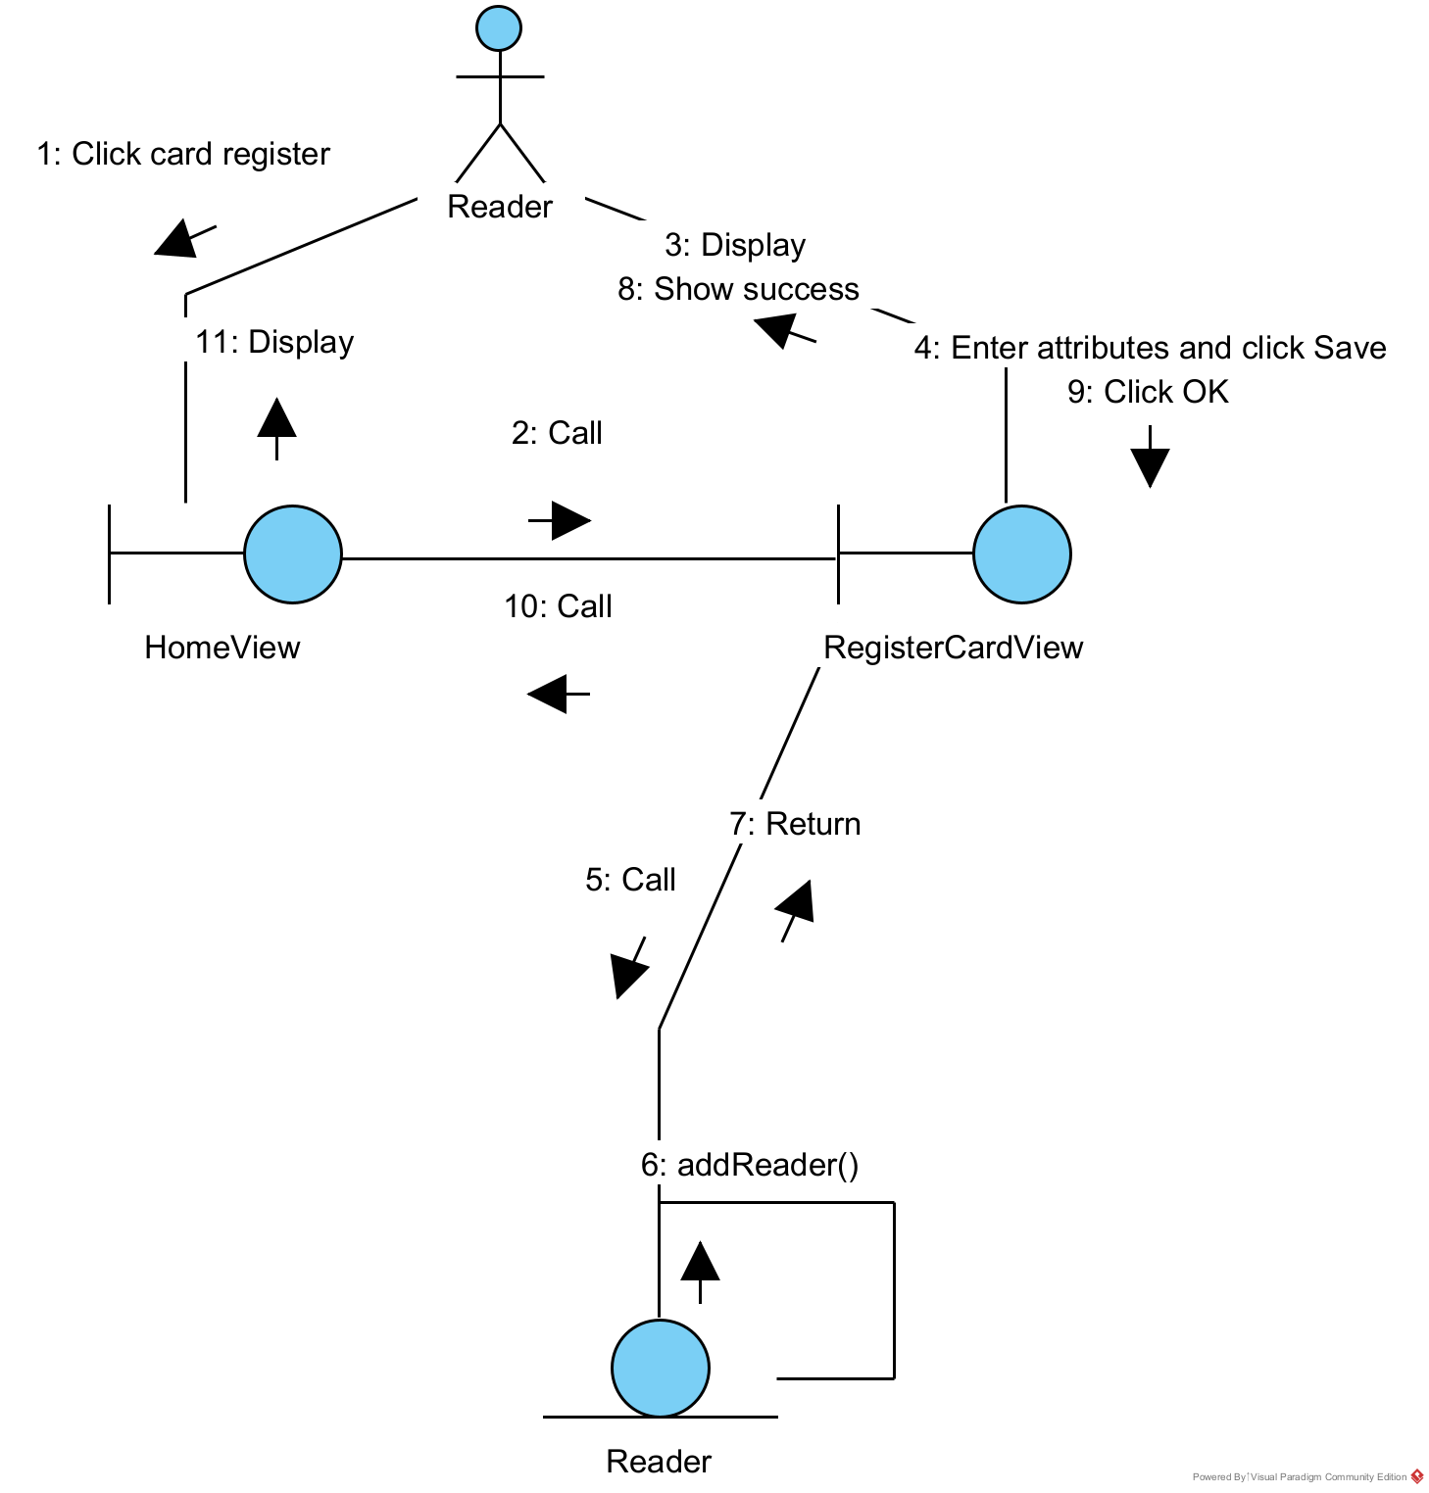
* Sequence diagram:
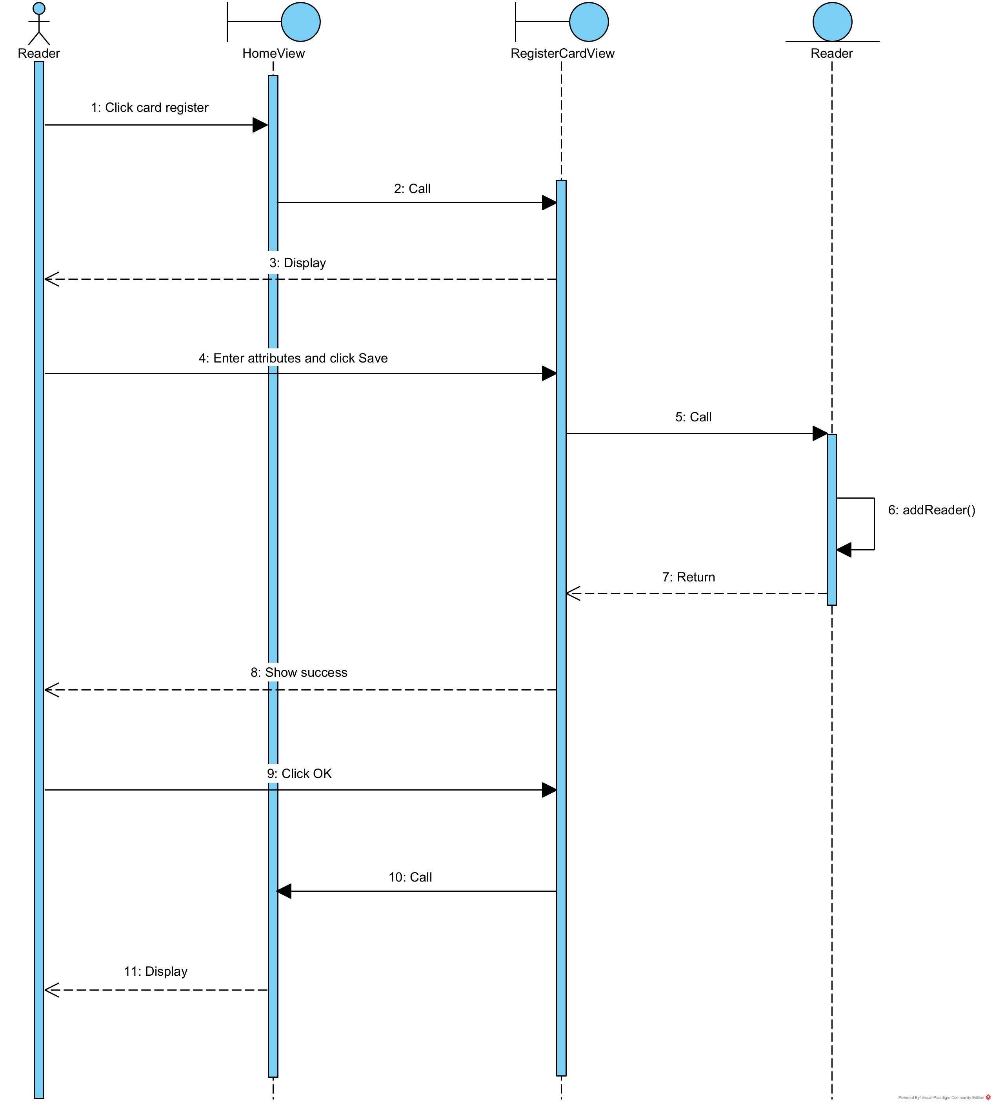

B. Module “Reader returns documents”
* Scenario version 2:
1. A reader approaches the library staff to return documents.
2. The library staff enters username/password and then clicks on the Login
button.
3. The class LoginView calls the class Staff to process.
4. The class Staff calls the method checkLogin(). The login is successful.
5. The class Staff returns the results to the class LoginView.
6. The class LoginView calls the class StaffHomeView.
7. The class StaffHomeView displays itself to the library staff.
8. The library staff chooses the option to return documents on the interface
StaffHomeView.
9. The class StaffHomeView calls the class SearchReaderView.
10. The class SearchReaderView shows to the library staff.
11. The library staff asks the reader about reader information.
12. The reader provides personal information to the library staff.
13. The library staff enters information and searches.
14. The SearchReaderView calls the Reader class.
15. The Reader class executes function searchReader().
16. The Reader class returns results to the SearchReaderView.
17. The SearchReaderView shows to the library staff.
18. The library staff clicks on the right reader.
19. The SearchReaderView calls BorrowedDocumentView.
20. The BorrowedDocumentView calls BorrowSlip class.
21. The BorrowSlip class executes function getBorrowedDocumentByReader().
22. The BorrowSlip returns results to BorrowedDocumentView.
23. The BorrowedDocumentView shows results to the library staff.
24. The library staff clicks the button to select the documents that the reader is returning then clicks Next button.
25. The BorrowedDocumentView calls SearchFineView.
26. The SearchFineView shows to the library staff.
27. The library staff enters the fine related to document damage on the SearchFineView.
28. The SearchFineView calls the Fine class.
29. The Fine class executes function searchFine().
30. The Fine class returns results to the SearchFineView.
31. The SearchFineView shows results to the library staff.
32. The library staff selects document fine and clicks on Make payment button.
33. The SearchFineView calls ConfirmReturnView.
34. The ConfirmReturnView shows to the library staff.
35. The library staff repeats returning information to the reader and asks to confirm.
36. The reader confirms to return.
37. The library staff clicks on Confirm button.
38. The ConfirmReturnView calls the ReturnSlip class.
39. The ReturnSlip class executes function addReturnSlip().
40. The ReturnSlip class returns result to the ConfirmReturnView.
41. The ConfirmReturnView calls the BorrowSlipDetail class.
42. The BorrowSlipDetail class executes function updateStatus().
43. The BorrowSlipDetail class returns result to the ConfirmReturnView.
44. The class ConfirmReturnView displays a successful message to the library staff.
45. The library staff clicks on the OK button of the message.
46. The class ConfirmReturnView calls the class StaffHomeView.
47. The class StaffHomeView displays itself to the library staff.
48. The library staff informs the successful return to the reader.
* Communication diagram:
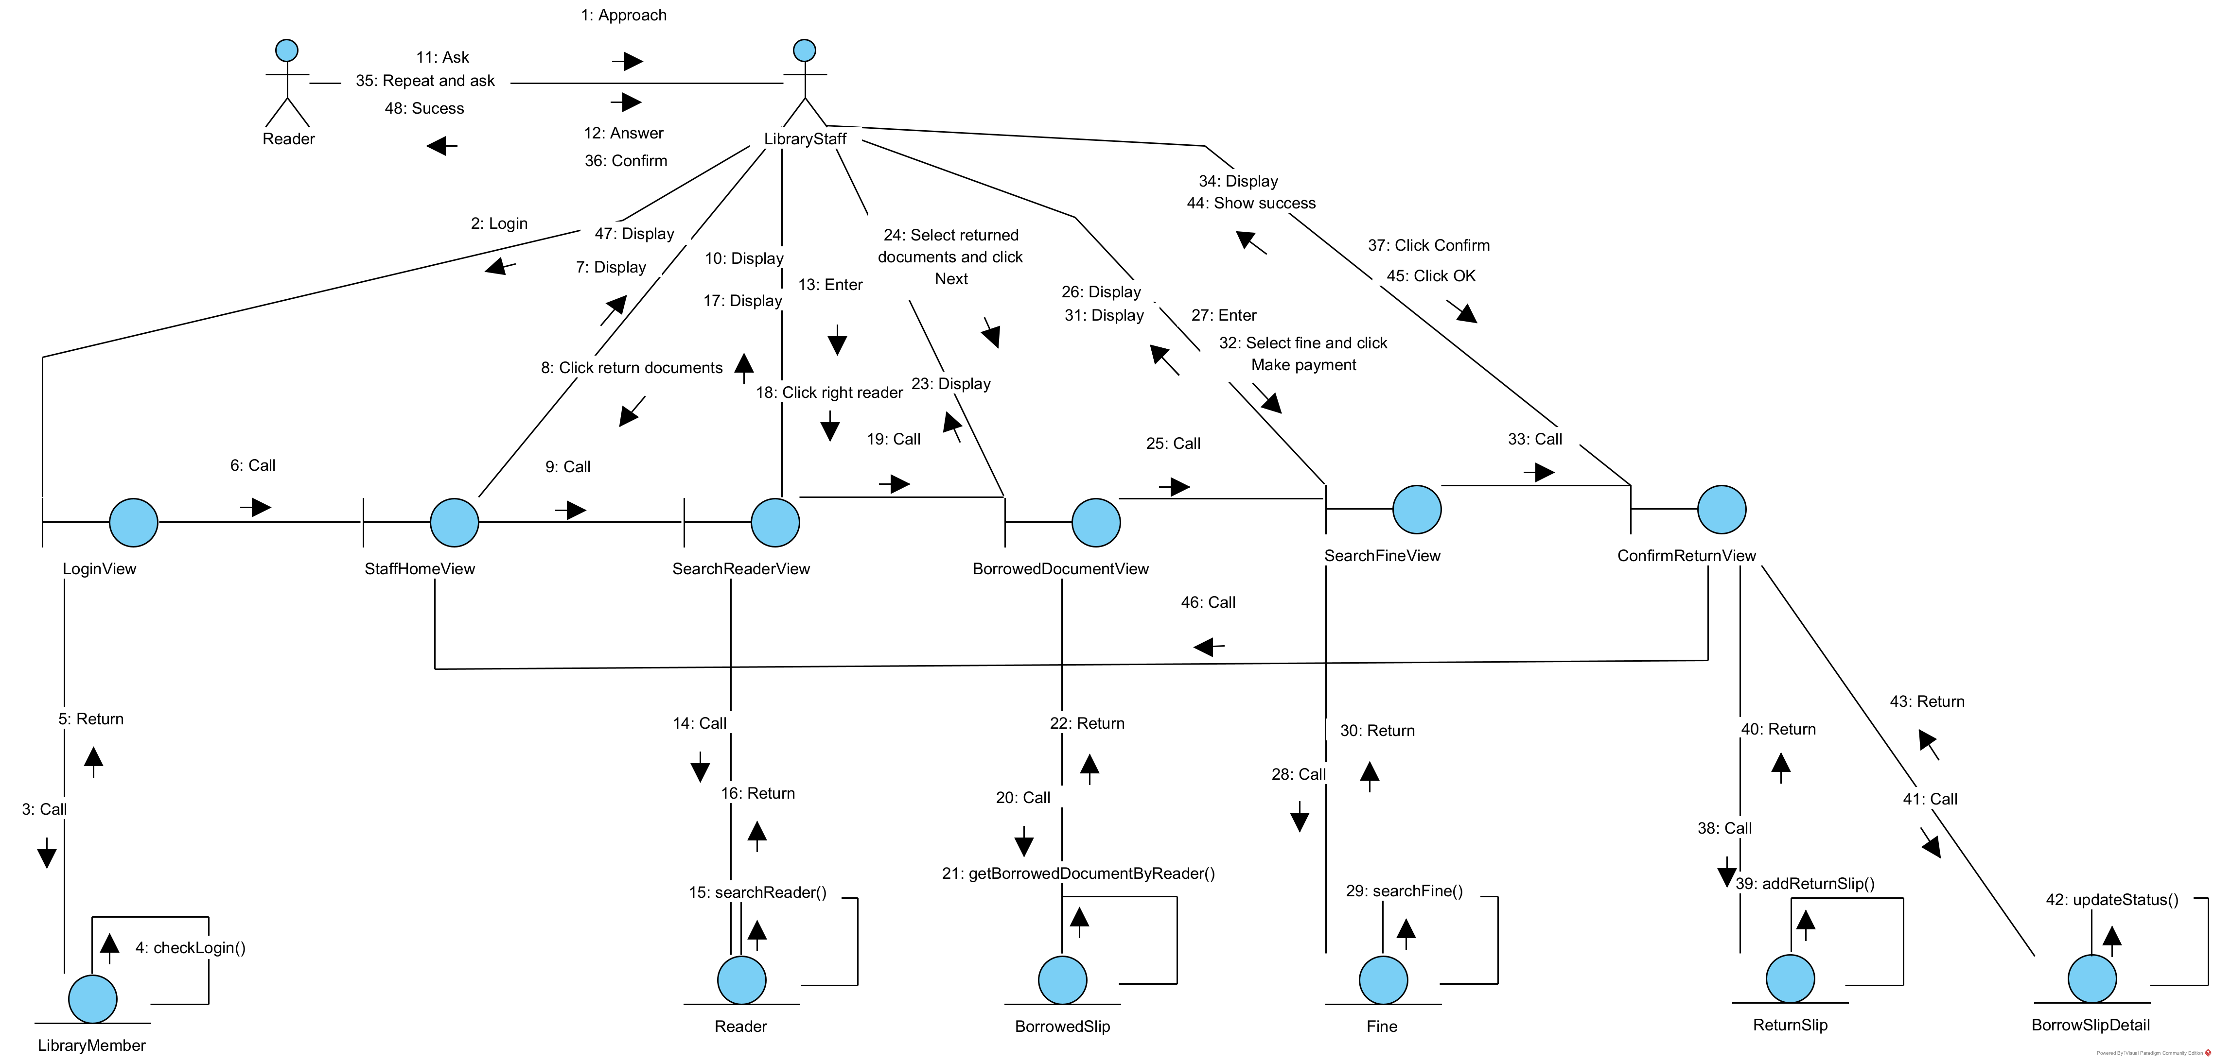
* Sequence diagram:


III. DESIGN

1. ENTITY CLASS DESIGN

A. Complete classes and attributes
- Add ID into classes that are not inherited from others: LibraryMember, ReaderCard, BorrowSlip, BorrowSlipDetail, ReturnSlip, ReturnSlipDetail, Fine, FineDetail, Document, DocumentCopy, Supplier, Invoice, ImportDocument.
- Add attribute type for all attributes.

B. Convert association relationship to aggregation/ composition
- DocumentCopy + BorrowSlip → BorrowSlipDetail is converted to: BorrowSlipDetail is a component of BorrowSlip, DocumentCopy is a component of BorrowSlipDetail.
- ReturnSlipDetail + Fine → FineDetail is converted to: FineDetail is a component of ReturnSlipDetail, Fine is a component of FineDetail.
- Invoice + DocumentCopy → ImportDocument is converted to: ImportDocument is a component of Invoice, DocumentCopy is a component of ImportDocument.

C. Add object attributes into classes corresponding to the relationships: aggregation/ composition
- ReaderCard is a component of Reader, of type 1 – 1 → Reader has a ReaderCard.
- Reader is a component of BorrowSlip, of type 1 – N → BorrowSlip has a Reader.
- BorrowSlipDetail is a component of BorrowSlip, of type N – 1 → BorrowSlip has a list of BorrowSlipDetail.
- Document is a component of DocumentCopy, of type 1 – N → DocumentCopy has a Document.
- DocumentCopy is a component of BorrowSlipDetail, of type 1 – N → BorrowSlipDetail has a DocumentCopy.
- ReturnSlipDetail is a component of ReturnSlip, of type N – 1 → ReturnSlip has a list of ReturnSlipDetail.
- Staff is a component of ReturnSlip, of type 1 – N → ReturnSlip has a Staff.
- BorrowSlipDetail is a component of ReturnSlipDetail, of type 1 – 1 → ReturnSlipDetail has a BorrowSlipDetail.
- FineDetail is a component of ReturnSlipDetail, of type N – 1 → ReturnSlipDetail has a list of FineDetail.
- Fine is a component of FineDetail, of type 1 – N → FineDetail has a Fine.
- Supplier is a component of Invoice, of type 1 – N → Invoice has a Supplier.
- Staff is a component of Invoice, of type 1 – N → Invoice has a Staff.
- ImportDocument is a component of Invoice, of type N – 1 → Invoice has a list of ImportDocument.
- DocumentCopy is a component of ImportDocument, of type 1 – N → ImportDocument has a DocumentCopy.


2. DATABASE DESIGN

A. Convert each class into a table
- Class LibraryMember → table tbl_LibraryMember
- Class Staff → table tbl_Staff
- Class Reader → table tbl_Reader
- Class ReaderCard → table tbl_ReaderCard
- Class BorrowSlip → table tbl_BorrowSlip
- Class BorrowSlipDetail → table tbl_BorrowSlipDetail
- Class ReturnSlip → table tbl_ReturnSlip
- Class ReturnSlipDetail → table tbl_ReturnSlipDetail
- Class Fine → table tbl_Fine
- Class FineDetail → table tbl_FineDetail
- Class DocumentCopy → table tbl_DocumentCopy
- Class Document → table tbl_Document
- Class Supplier → table tbl_Supplier
- Class Invoice→ table tbl_Invoice
- Class ImportDocument → table tbl_ImportDocument
- Class ReaderStat → table tbl_ReaderStat
- Class DocumentStat → table tbl_DocumentStat
- Class SupplierStat → table tbl_SupplierStat

B. Make non – object attributes of entity class become attributes of corresponding table
- tbl_LibraryMember: ID, username, password, fullName, dateOfBirth, address, phoneNumber
- tbl_Staff: role
- tbl_ReaderCard: ID, issueDate, expiryDate
- tbl_BorrowSlip: ID, borrowDate, note
- tbl_BorrowSlipDetail: ID, dueDate, isReturned
- tbl_ReturnSlip: ID, returnDate, totalFine
- tbl_ReturnSlipDetail: ID, overdueDays
- tbl_Fine: ID, name, amount
- tbl_FineDetail: ID, note
- tbl_DocumentCopy: ID, barcode, condition
- tbl_Document: ID, title, author, category, description, quantity
- tbl_Supplier: ID, name, email, phoneNumber, address
- tbl_Invoice: ID, importedDate, totalPrice
- tbl_ImportDocument: ID, amount, price
- tbl_ReaderStat: totalDocumentBorrowed
- tbl_DocumentStat: totalNumOfLoan
- tbl_SupplierStat: totalImportVolume

C. Make all quantitative relationships among classes become quantitative relationships among tables
- 1 tbl_LibraryMember – 1 tbl_Staff
- 1 tbl_LibraryMember – 1 tbl_Reader
- 1 tbl_Reader – 1 tbl_ReaderCard
- 1 tbl_Reader – N tbl_BorrowSlip
- 1 tbl_BorrowSlip – N tbl_BorrowSlipDetail
- 1 tbl_Document – N tbl_DocumentCopy
- 1 tbl_DocumentCopy – N tbl_BorrowSlipDetail
- 1 tbl_Reader – N tbl_ReturnSlip
- 1 tbl_Staff – N tbl_ReturnSlip
- 1 tbl_ReturnSlip – N tbl_ReturnSlipDetail
- 1 tbl_BorrowSlipDetail – 1 tbl_ReturnSlipDetail
- 1 tbl_ReturnSlipDetail – N tbl_FineDetail
- 1 tbl_Fine – N tbl_FineDetail
- 1 tbl_Supplier – N tbl_Invoice
- 1 tbl_Staff – N tbl_Invoice
- 1 tbl_Invoice – N tbl_ImportDocument
- 1 tbl_DocumentCopy – N tbl_ImportDocument
- 1 tbl_Reader – 1 tbl_ReaderStat
- 1 tbl_Document – 1 tbl_DocumentStat
- 1 tbl_Supplier – 1 tbl_SupplierStat

D. Add key attributes
- Primary key is set with ID attribute of corresponding tables.
- Foreign keys are set up for the tables:
+ 1 tbl_LibraryMember – 1 tbl_Staff → table tbl_Staff has a foreign key tbl_LibraryMemberID
+ 1 tbl_LibraryMember – 1 tbl_Reader → table tbl_Reader has a foreign key tbl_LibraryMemberID
+ 1 tbl_Reader – 1 tbl_ReaderCard → table tbl_ReaderCard has a foreign key tbl_ReaderID
+ 1 tbl_Reader – N tbl_BorrowSlip → table tbl_BorrowSlip has a foreign key tbl_ReaderID
+ 1 tbl_BorrowSlip – N tbl_BorrowSlipDetail → table tbl_BorrowSlipDetail has a foreign key tbl_BorrowSlipID
+ 1 tbl_Document – N tbl_DocumentCopy → table tbl_DocumentCopy has a foreign key tbl_DocumentID
+ 1 tbl_DocumentCopy – N tbl_BorrowSlipDetail → table tbl_BorrowSlipDetail has a foreign key tbl_DocumentCopyID
+ 1 tbl_Reader – N tbl_ReturnSlip → table tbl_ReturnSlip has a foreign key tbl_ReaderID
+ 1 tbl_Staff – N tbl_ReturnSlip → table tbl_ReturnSlip has a foreign key tbl_StaffID
+ 1 tbl_ReturnSlip – N tbl_ReturnSlipDetail → table tbl_ReturnSlipDetail has a foreign key tbl_ReturnSlipID
+ 1 tbl_BorrowSlipDetail – 1 tbl_ReturnSlipDetail → table tbl_ReturnSlipDetail has a foreign key tbl_BorrowSlipDetailID
+ 1 tbl_ReturnSlipDetail – N tbl_FineDetail → table tbl_FineDetail has a foreign key tbl_ReturnSlipDetailID
+ 1 tbl_Fine – N tbl_FineDetail → table tbl_FineDetail has a foreign key tbl_FineID
+ 1 tbl_Supplier – N tbl_Invoice → table tbl_Invoice has a foreign key tbl_SupplierID
+ 1 tbl_Staff – N tbl_Invoice → table tbl_Invoice has a foreign key tbl_StaffID
+ 1 tbl_Invoice – N tbl_ImportDocument → table tbl_ImportDocument has a foreign key tbl_InvoiceID
+ 1 tbl_DocumentCopy – N tbl_ImportDocument → table tbl_ImportDocument has a foreign key tbl_DocumentCopyID

E. Eliminate redundancy attributes
- Duplicate:
There is no duplicate attribute.
- Secondary:
+ tbl_ReaderStat, tbl_DocumentStat, tbl_SupplierStat because they are statistic tables
+ totalFine from tbl_ReturnSlip because it could be calculated from tbl_ReturnSlipDetail
+ totalPrice from tbl_Invoice because it could be calculated from a formula: quantity x price
+ expiryDate from tbl_ReaderCard because it could be calculated from a formula: issueDate + 1 year
+ overdueDays from tbl_ReturnSlipDetail because it could be calculated from a formula: returnDate - dueDate
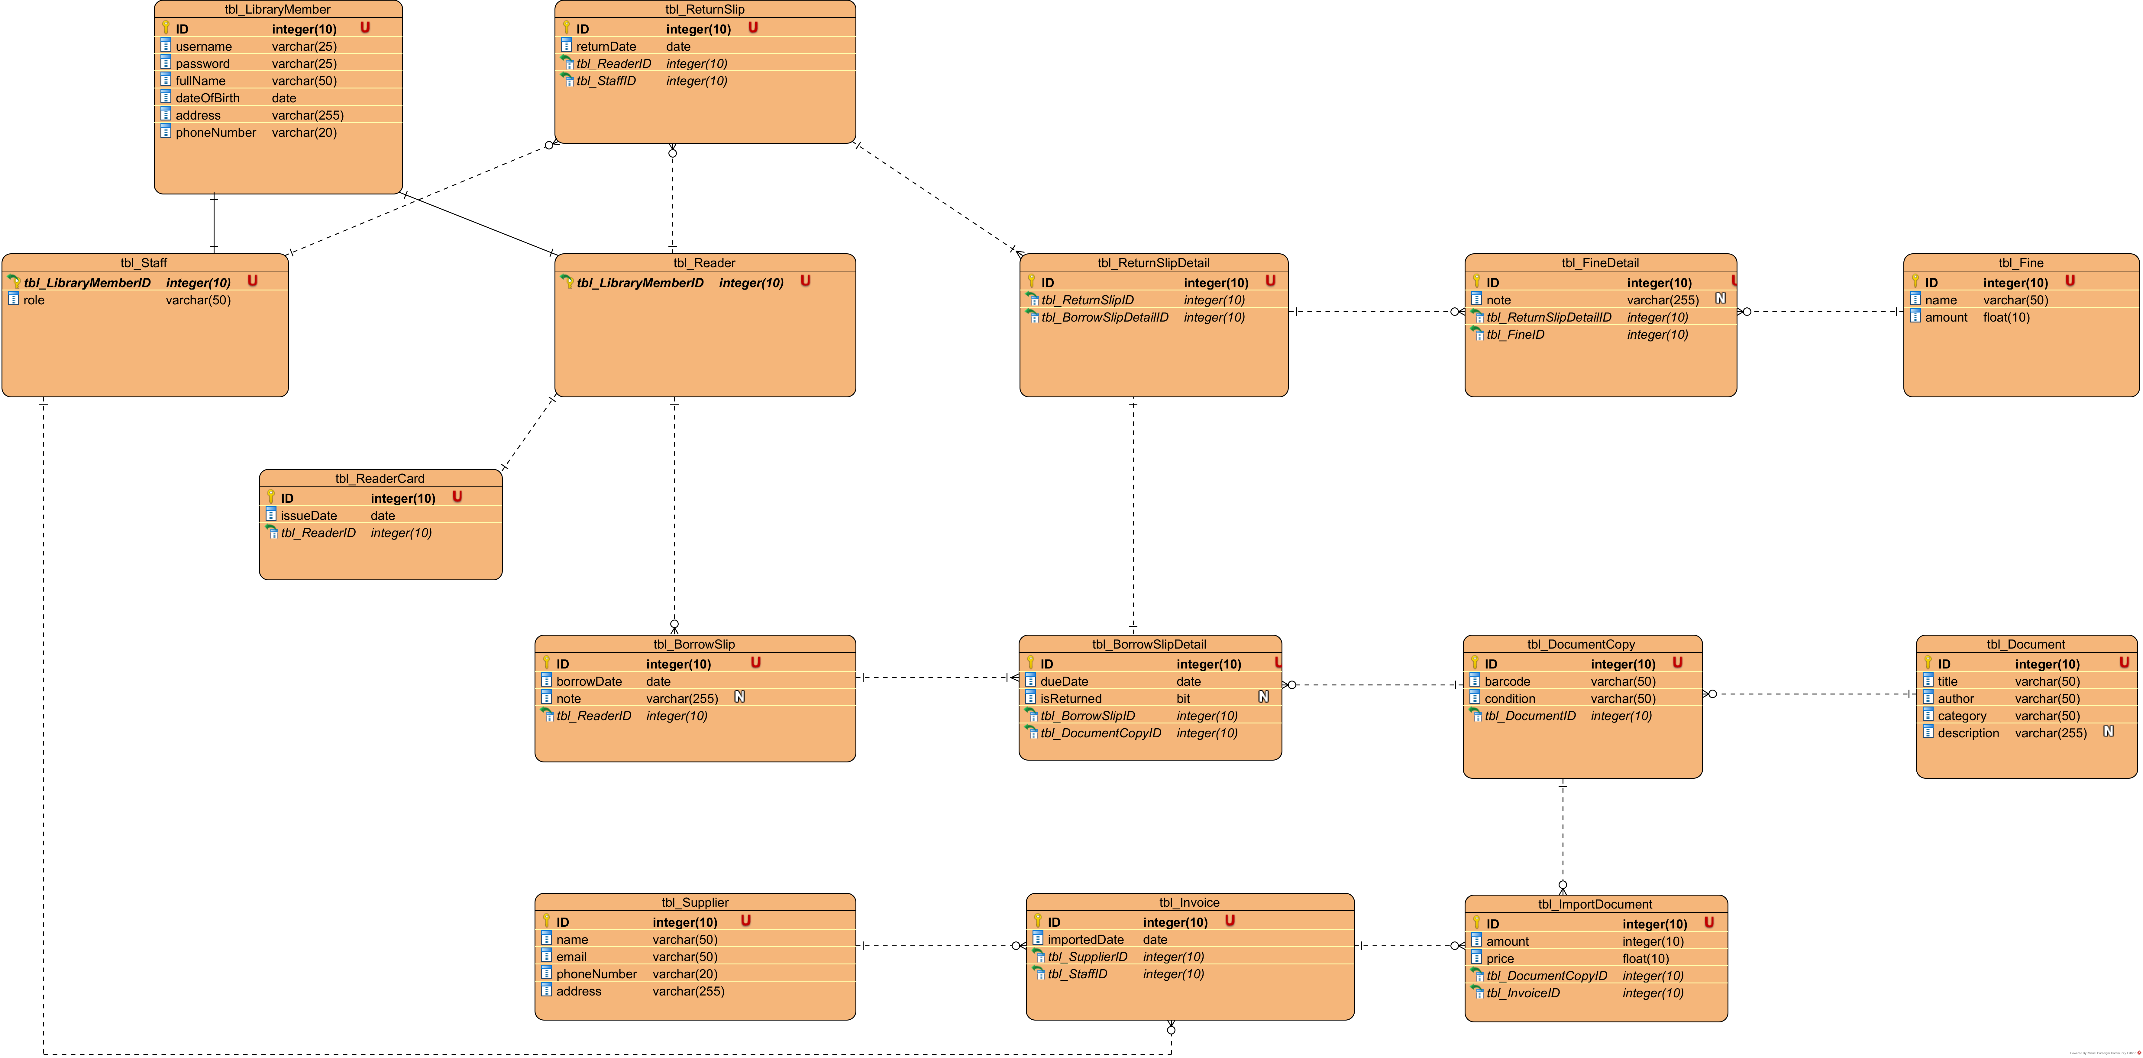

3. CLASS DESIGN DIAGRAM

A. Module “Reader registers as a reader card”
* Interface design:
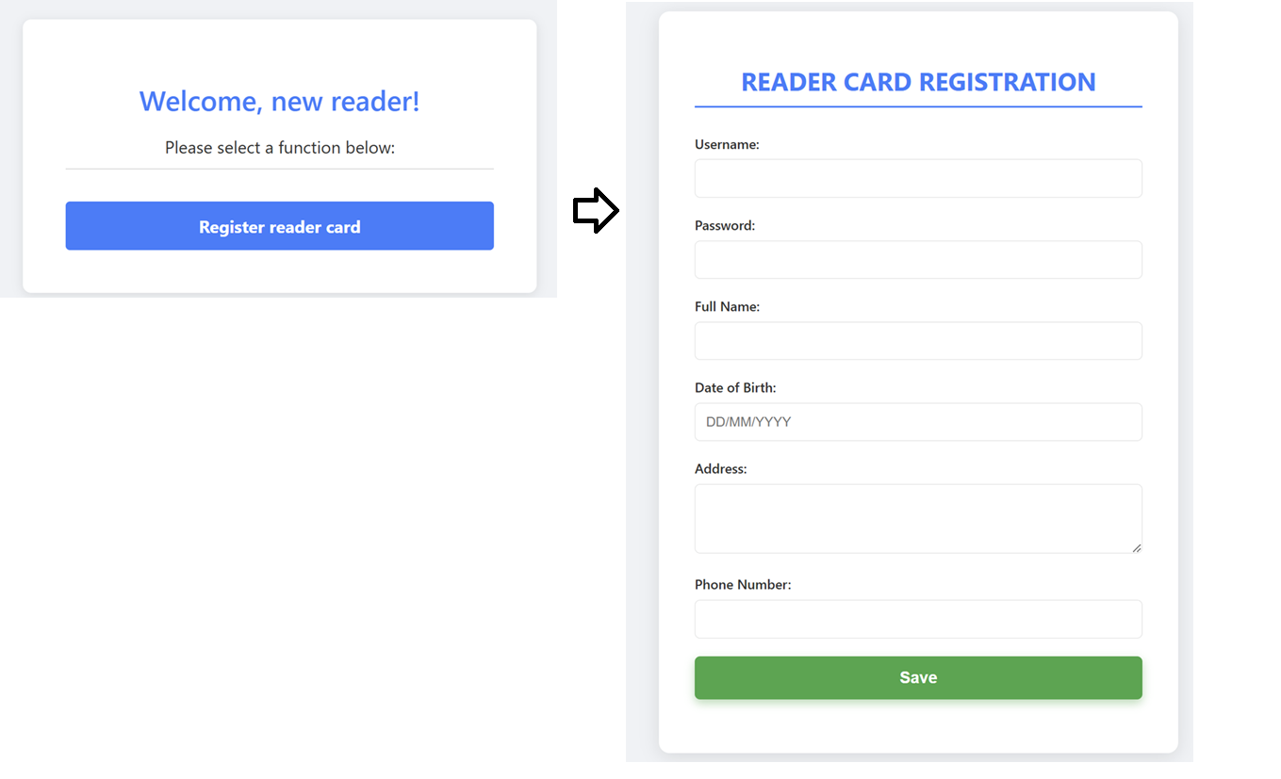

* Class design diagram:
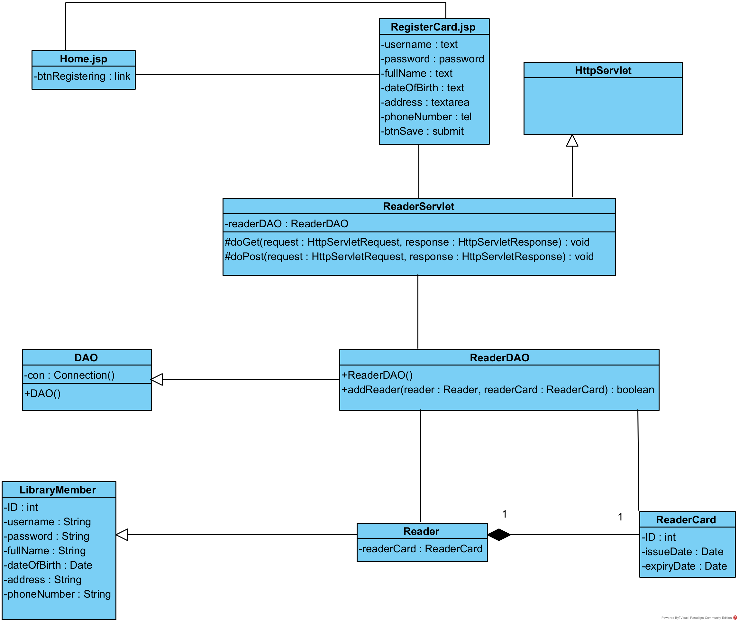

B. Module “Reader returns documents”
* Interface design:
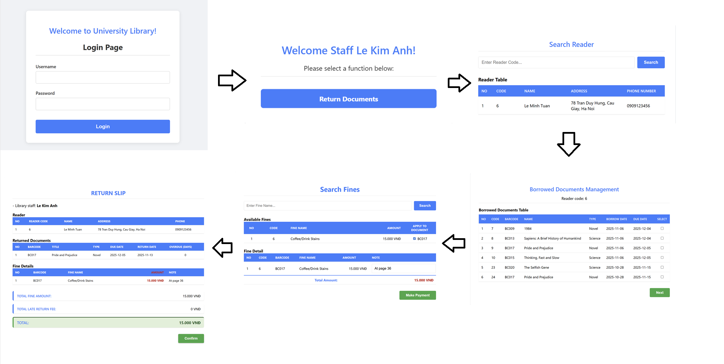
* Class design diagram:
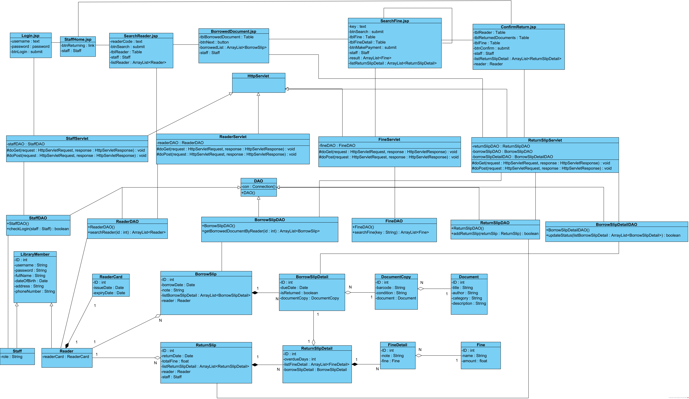

4. ACTIVITY DIAGRAM

A. Module “Reader registers as a reader card”
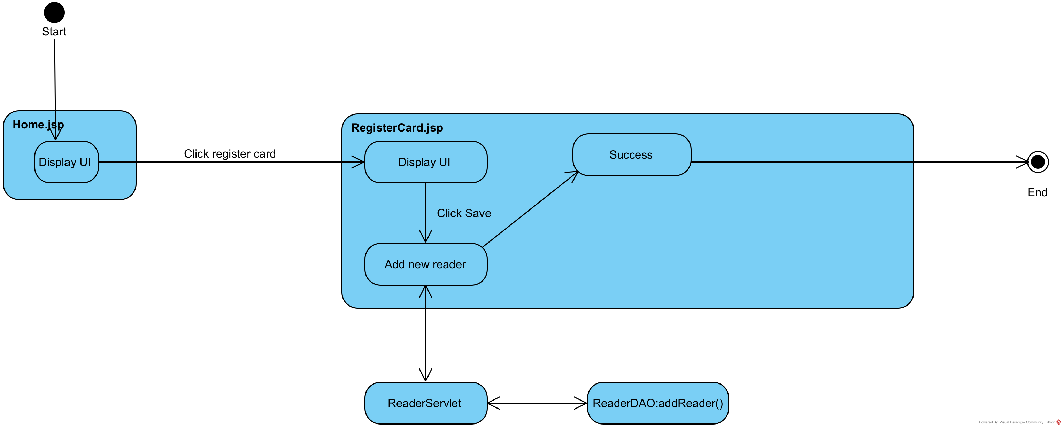

B. Module “Reader returns documents”
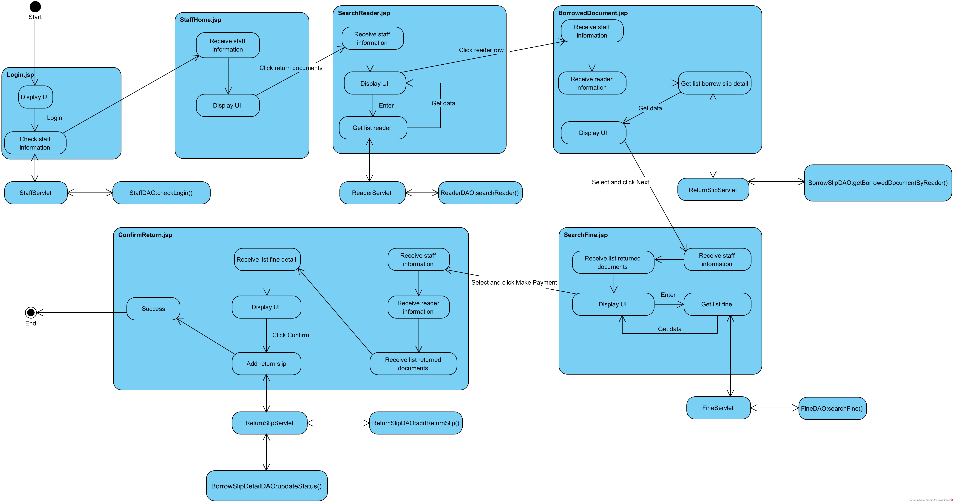

5. SEQUENCE DIAGRAM

A. Module “Reader registers as a reader card”
* Scenario version 3:
1. A reader clicks on the registering reader card function on Home.jsp.
2. Home.jsp calls RegisterCard.jsp.
3. RegisterCard.jsp is shown to the staff.
4. A reader enters all attributes and clicks Save.
5. RegisterCard.jsp calls the class ReaderServlet.
6. The class ReaderServlet calls the method doPost().
7. The method doPost() calls the class Reader to add reader information to it.
8. The class Reader calls its setter method.
9. The class Reader returns the packed object to the method doPost().
10. The method doPost() calls the class ReaderCard to add reader information to it.
11. The class ReaderCard calls its setter method.
12. The class ReaderCard returns the packed object to the method doPost().
13. The method doPost() calls the method addReader() of the class ReaderDAO.
14. The method addReader() executes.
15. The method addReader() returns results to the method doPost().
16. The method doPost() forwards the request back to RegisterCard.jsp to display the result message.
17. RegisterCard.jsp shows success message to the reader.
18. The reader clicks OK button of the message.
19. RegisterCard.jsp calls Home.jsp.
20. Home.jsp is shown to the reader.
* Sequence diagram:
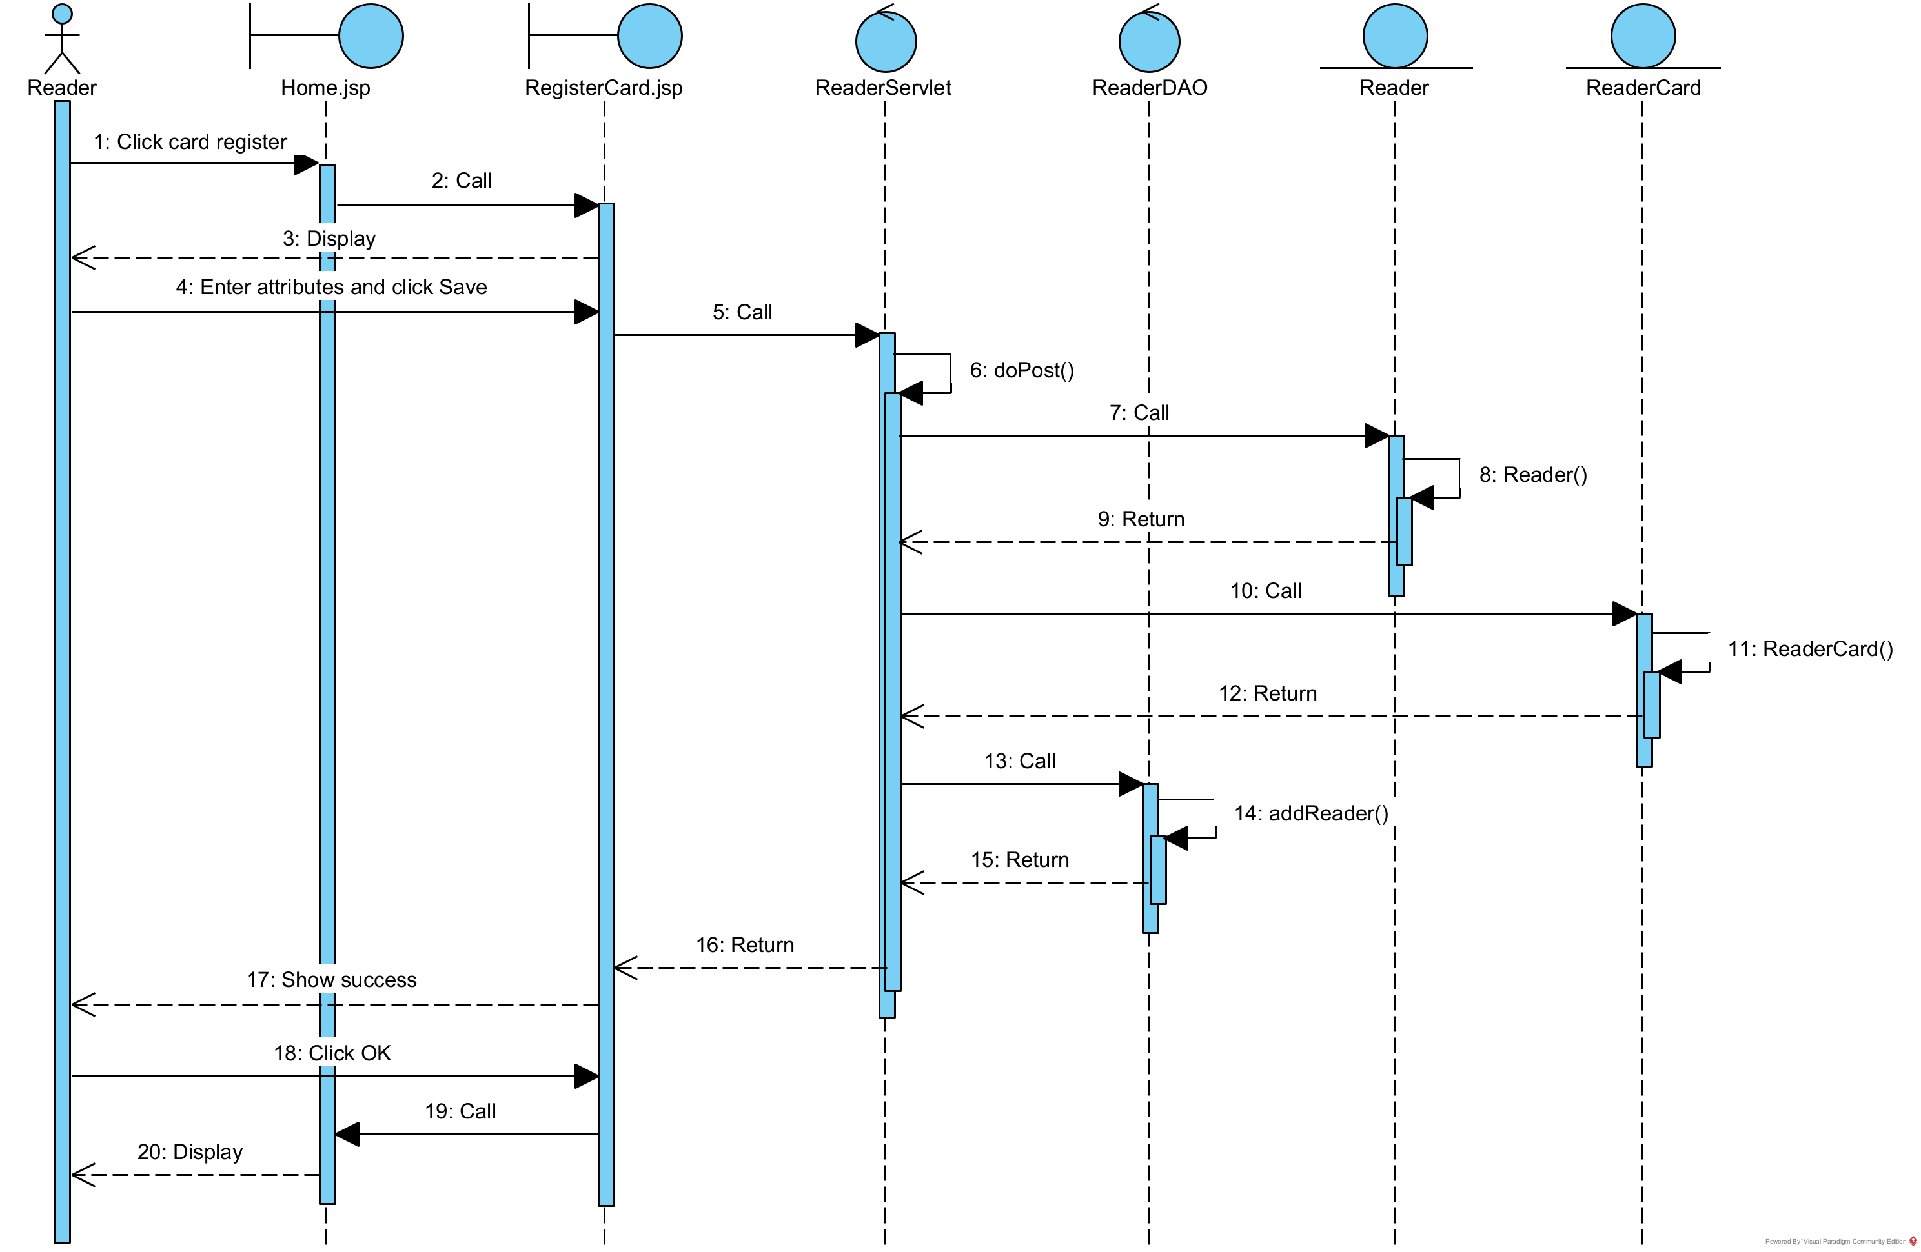

B. Module “Reader returns documents”
* Scenario version 3:
1. A reader approaches the library staff to return documents.
2. A library staff enters his username, password, and clicks on the login button on Login.jsp.
3. Login.jsp calls the class StaffServlet.
4. The class StaffServlet calls the method doPost().
5. The method doPost() calls the class Staff to create a Staff object.
6. The class Staff packs the information into a Staff object.
7. The class Staff returns Staff object to the method doPost().
8. The method doPost() calls method checkLogin() of the class StaffDAO.
9. The method checkLogin() checks the login information.
10. The method checkLogin() calls the class Staff to set more three attributes: ID, fullName, role.
11. The class Staff calls its method setID(), setFullName(), setRole().
12. The class Staff returns the Staff object to the method checkLogin().
13. The method checkLogin() returns the results to the method doPost().
14. The method doPost() forwards the request back to StaffHome.jsp.
15. StaffHome.jsp is shown to the staff.
16. A staff clicks on the returning documents function on StaffHome.jsp.
17. StaffHome.jsp calls SearchReader.jsp.
18. SearchReader.jsp is shown to the staff.
19. The library staff asks the reader about his information.
20. The reader provides it to the library staff.
21. The library staff enters the reader code and clicks Search.
22. SearchReader.jsp calls the class ReaderServlet.
23. The class ReaderServlet calls the method doGet().
24. The method doGet() calls the method searchReader() of the class ReaderDAO.
25. The method searchReader() executes.
26. The method searchReader() calls the class Reader to pack the results.
27. The class Reader packs a Reader object.
28. The class Reader returns the packed object to the method searchReader().
29. The method searchReader() returns the results to the method doGet().
30. The method doGet() forwards the request back to SearchReader.jsp.
31. SearchReader.jsp displays the results to the library staff.
32. The library staff clicks on the row corresponding to the current reader.
33. SearchReader.jsp calls the class ReturnSlipServlet.
34. The class ReturnSlipServlet calls the method doGet().
35. The method doGet() calls the method getBorrowedDocumentByReader() of the class BorrowSlipDAO.
36. The method getBorrowedDocumentByReader() executes.
37. The method getBorrowedDocumentByReader() calls the class BorrowSlip to pack the results.
38. The class BorrowSlip packs its attributes.
39. The class BorrowSlip calls the class BorrowSlipDetail to pack its object attributes.
40. The class BorrowSlipDetail packs its attributes.
41. The class BorrowSlipDetail calls the class DocumentCopy to pack its object attributes.
42. The class DocumentCopy packs its attributes.
43. The class DocumentCopy calls the class Document to pack its object attributes.
44. The class Document packs its attributes.
45. The class Document returns the packed object to the class DocumentCopy.
46. The class DocumentCopy returns the packed object to the class BorrowSlipDetail.
47. The class BorrowSlipDetail returns the packed object to the class BorrowSlip.
48. The class BorrowSlip returns the packed object to the method getBorrowedDocumentByReader().
49. The method getBorrowedDocumentByReader() returns the results to the method doGet().
50. The method doGet() forwards the request back to BorrowedDocument.jsp.
51. BorrowedDocument.jsp displays the results to the library staff.
52. The library staff selects documents to return and click Next.
53. BorrowDocument.jsp calls the class ReturnSlipServlet.
54. The class ReturnSlipServlet calls the method doPost().
55. The method doPost() calls the class ReturnSlipDetail to add document information to it.
56. The class ReturnSlipDetail calls its setter method and setBorrowSlipDetail().
57. The class ReturnSlipDetail returns the packed object to the method doPost().
58. The method doPost() forwards the request back to SearchFine.jsp.
59. SearchFine.jsp is shown to the library staff.
60. The library staff enters the fine and clicks Search.
61. SearchFine.jsp calls the class FineServlet.
62. The class FineServlet calls the method doGet().
63. The method doGet() calls the method searchFine() of the class FineDAO.
64. The method searchFine() executes.
65. The method searchFine() calls the class Fine to pack the results.
66. The class Fine packs a Fine object.
67. The class Fine returns the packed object to the method searchFine().
68. The method searchFine() returns the results to the method doGet().
69. The method doGet() forwards the request back to SearchFine.jsp.
70. SearchFine.jsp displays the results to the library staff.
71. The librarian selects the fines corresponding to the return and clicks Make payment.
72. SearchFine.jsp calls the class FineServlet.
73. The class FineServlet calls the method doPost().
74. The method doPost() calls the class FineDetail to add fine information to it.
75. The class FineDetail calls its setter method and setFine().
76. The class FineDetail returns the packed object to the method doPost().
77. The method doPost() calls the class ReturnSlipDetail to add fine detail information to it.
78. The class ReturnSlipDetail calls the method setFineDetail().
79. The class ReturnSlipDetail returns the packed object to the method doPost().
80. The method doPost() forwards the request back to ConfirmReturn.jsp.
81. ConfirmReturn.jsp is shown to the library staff.
82. The library staff repeats the information to the reader and asks to confirm.
83. The reader confirms.
84. The library staff clicks on the Confirm button.
85. ConfirmReturn.jsp calls the class ReturnSlipServlet.
86. The class ReturnSlipServlet calls the method doPost().
87. The method doPost() calls the class ReturnSlip to add return slip detail information to it.
88. The class ReturnSlip calls its setter method.
89. The class ReturnSlip returns the packed object to the method doPost().
90. The method doPost() calls the method addReturnSlip() of the class ReturnSlipDAO.
91. The method addReturnSlip() executes.
92. The method addReturnSlip() returns results to the method doPost().
93. The method doPost() calls the class BorrowSlipDetail to update borrow slip detail information.
94. The class BorrowSlipDetail calls its setter method.
95. The class BorrowSlipDetail returns the packed object to the method doPost().
96. The method doPost() calls the method updateStatus() of the class BorrowSlipDetailDAO.
97. The method updateStatus() executes.
98. The method updateStatus() returns results to the method doPost().
99. The method doPost() forwards the request back to ConfirmReturn.jsp.
100. ConfirmReturn.jsp shows success message to the library staff.
101. The library staff clicks OK button of the message.
102. ConfirmReturn.jsp calls StaffHome.jsp.
103. StaffHome.jsp is shown to the library staff.
104. The library staff confirms success to the reader.


6. PACKAGE DIAGRAM
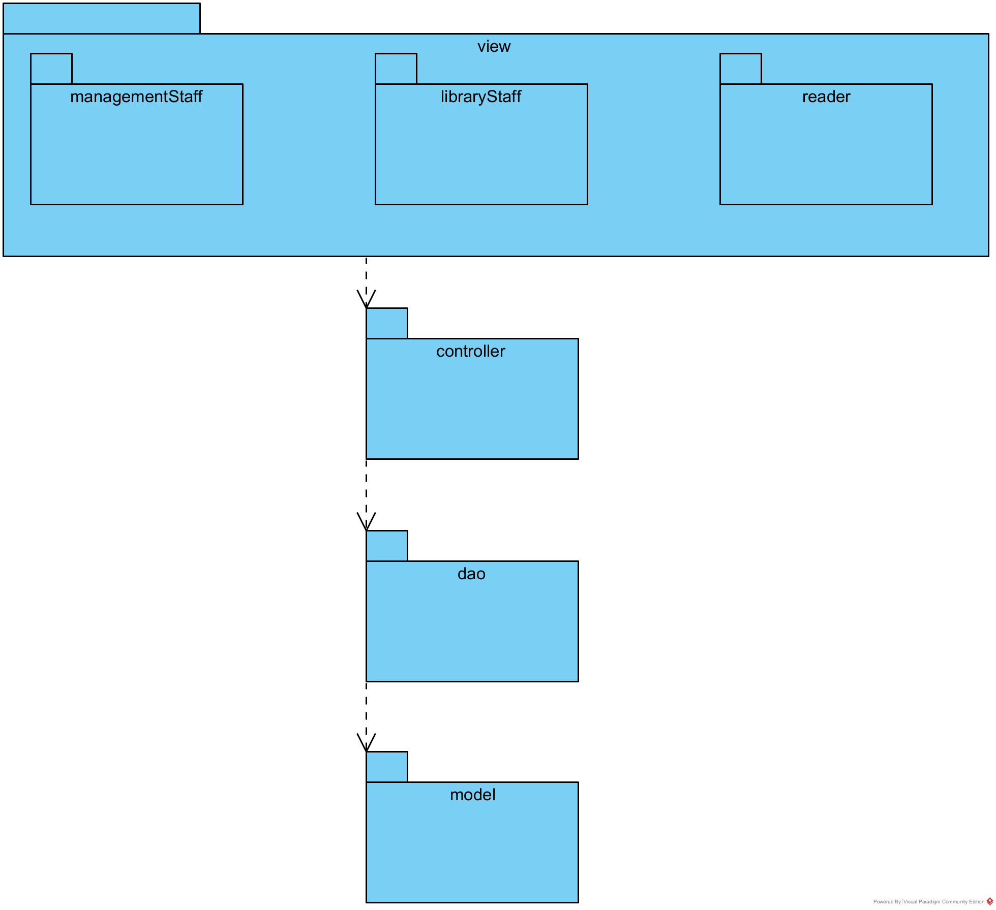

7. DEPLOYMENT DIAGRAM
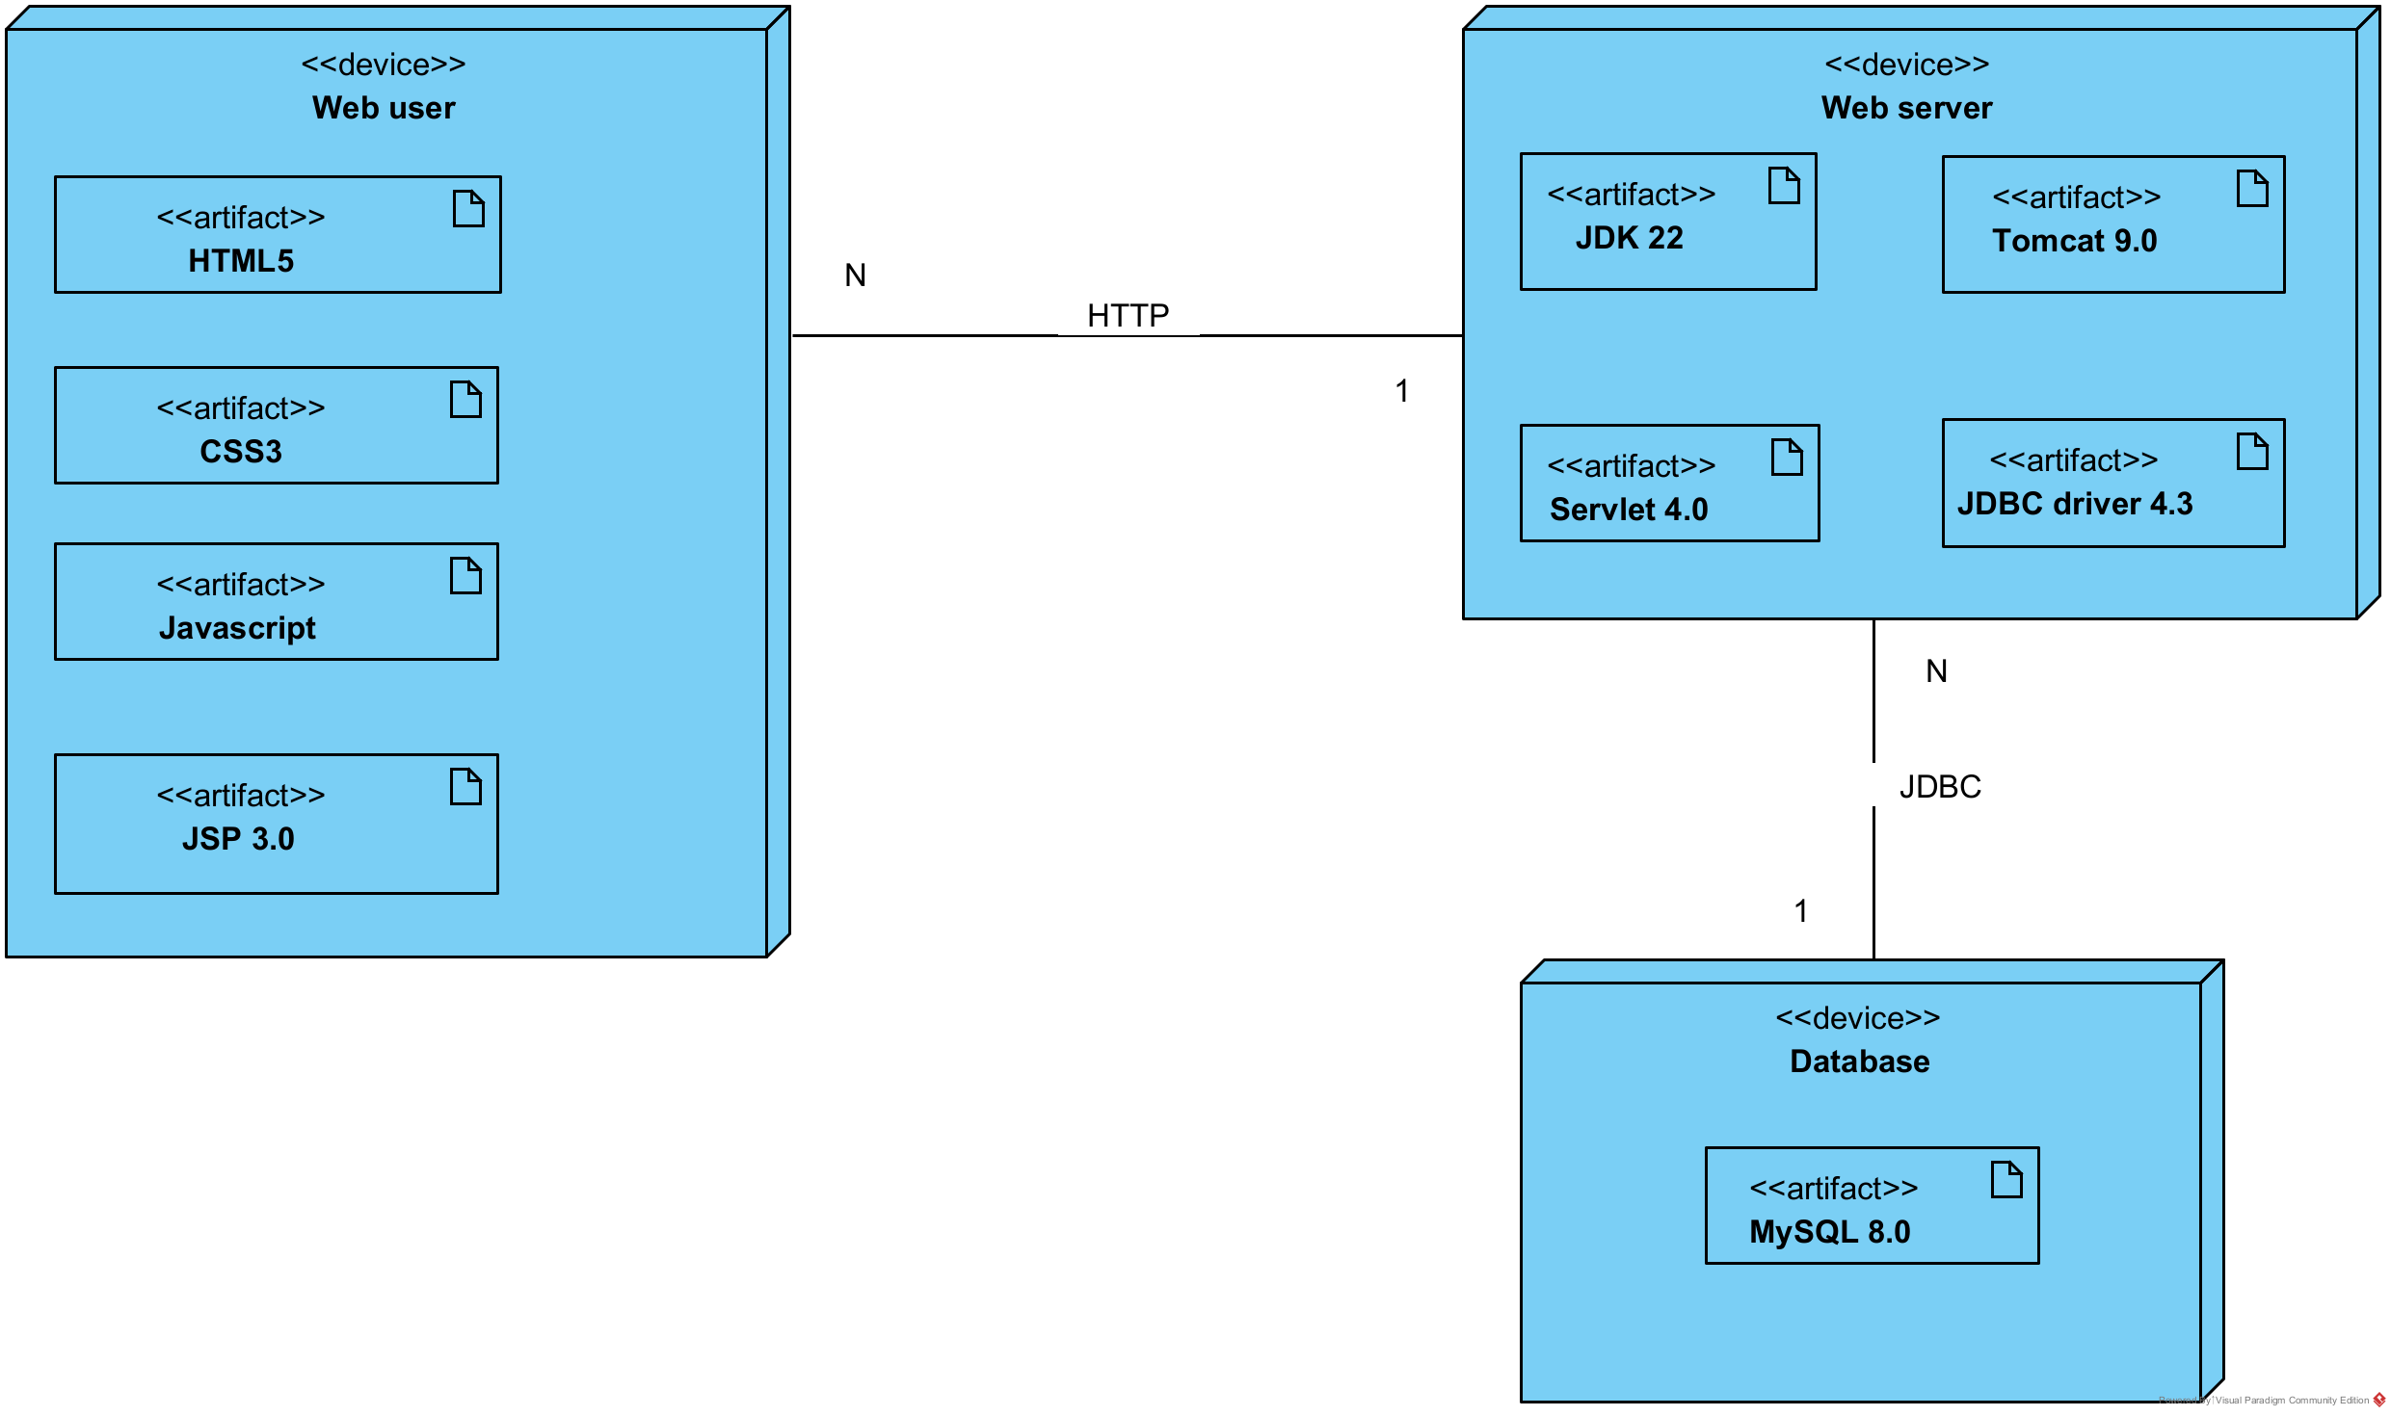

IV. CODING

1. UI

A. Module “Reader registers as a reader card”
- The reader accesses the library management system, and the system will display the home interface.
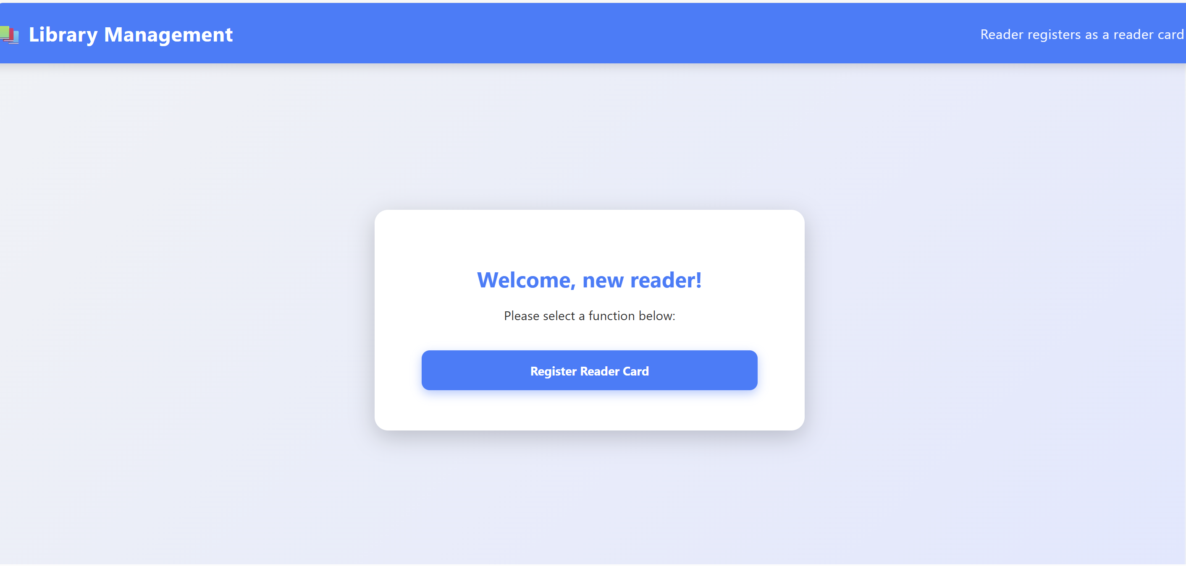
- The reader clicks to select Register Reader Card → The system shows the Reader Card Registration interface, including the personal information fields that need to be filled in.
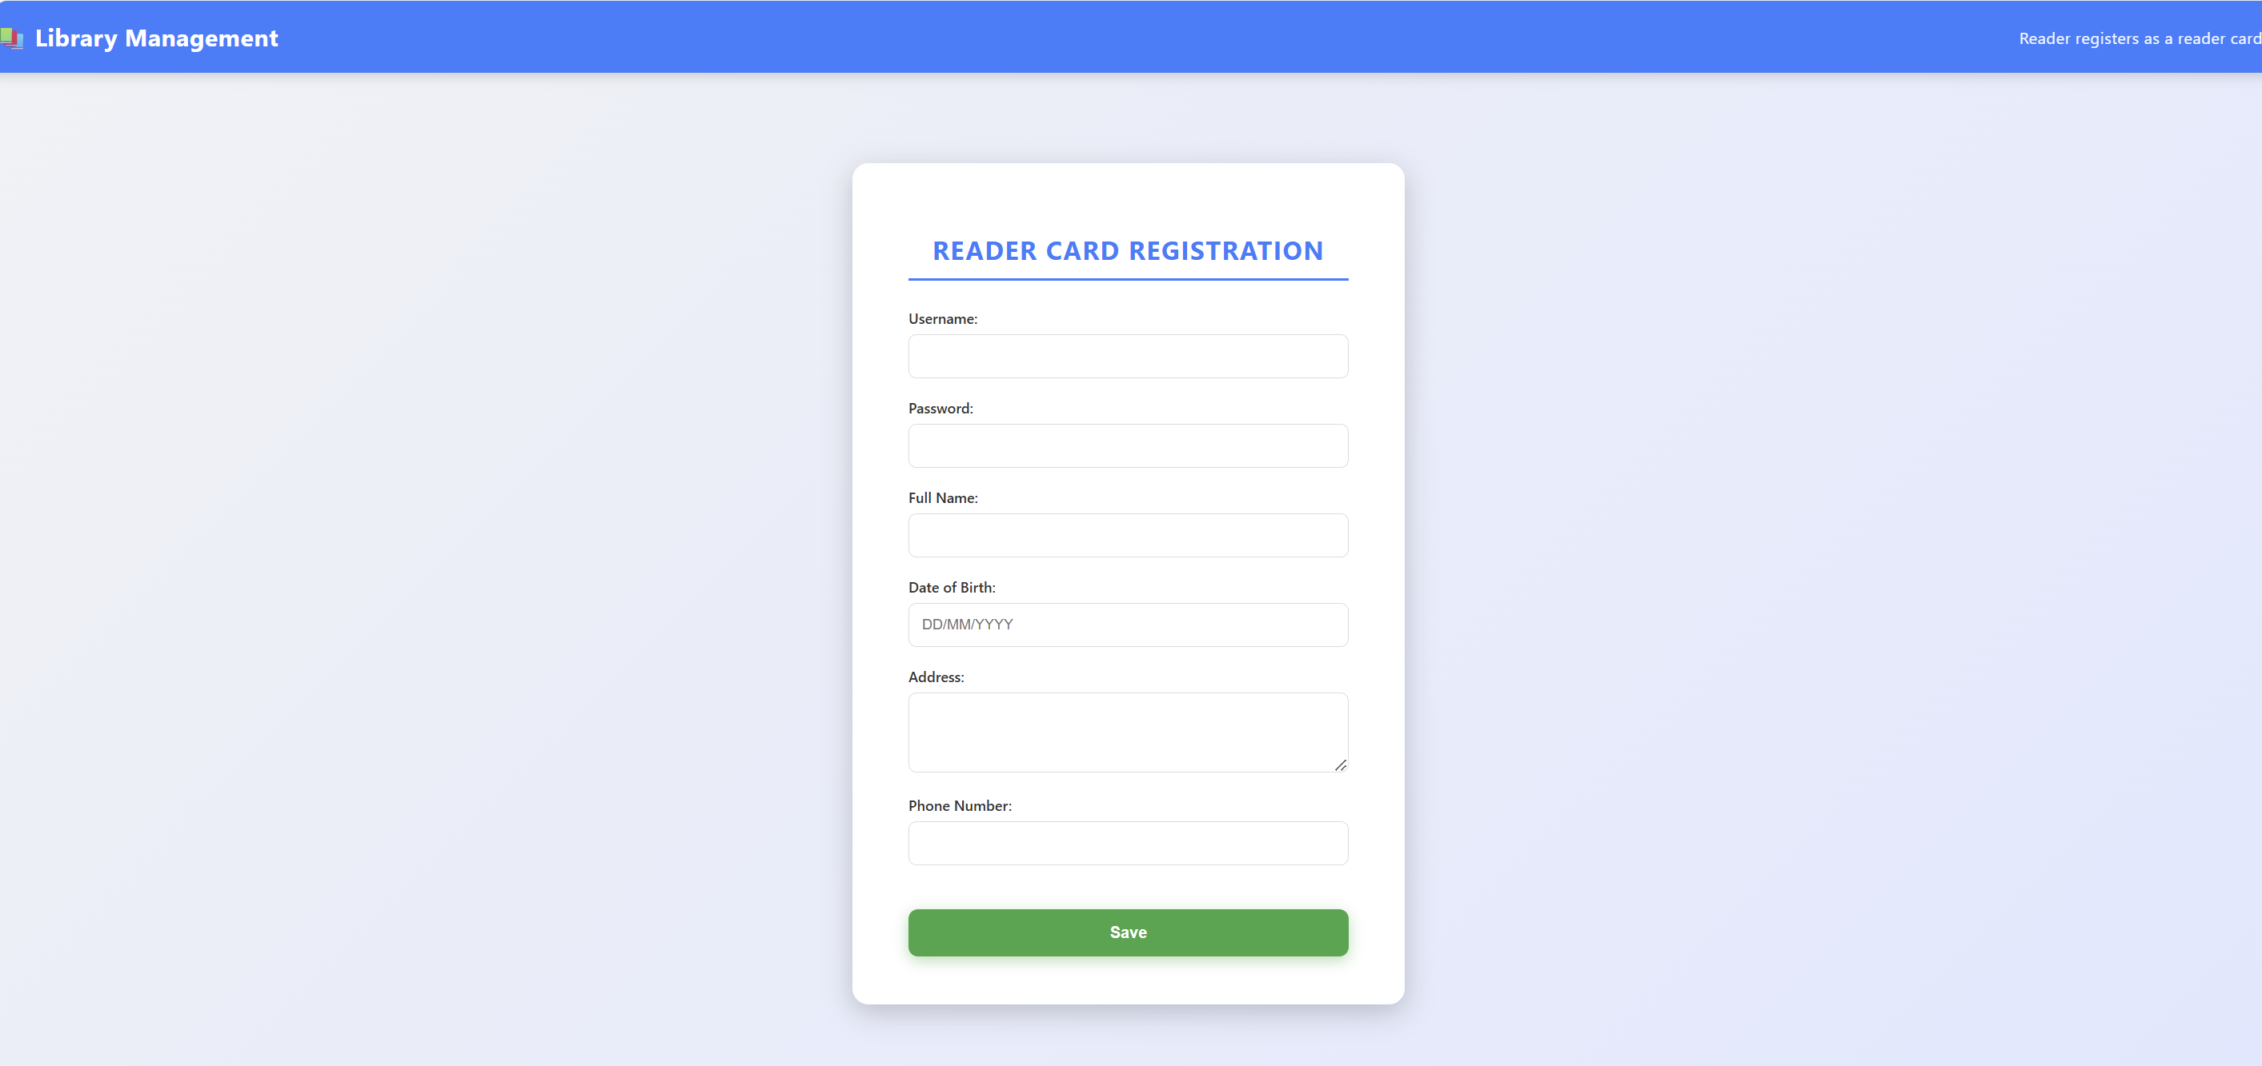
- Then the reader enters the information and clicks the Save button. The system will display certain exceptions, such as incomplete information or invalid input.
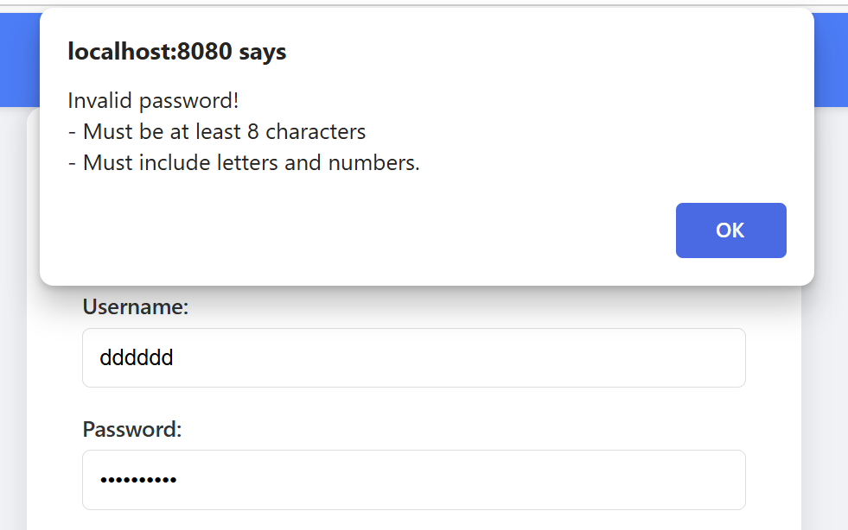

- When the reader clicks Save, the system saves the data into the database and shows a success message.
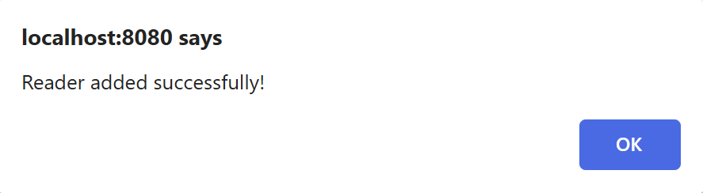

B. Module “Reader returns documents”
- The staff accesses the library management system, and the system will display the login interface.
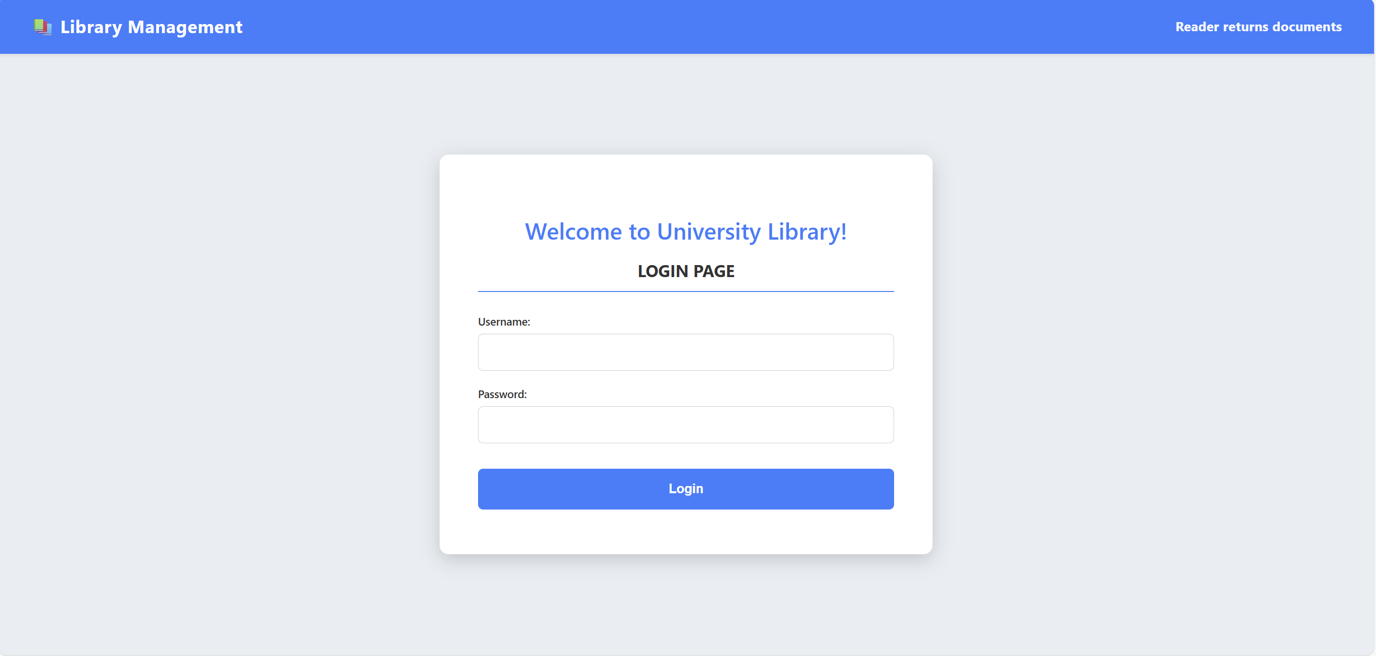
- When the staff logs in successfully, the system will show the main screen with available functions for the staff.
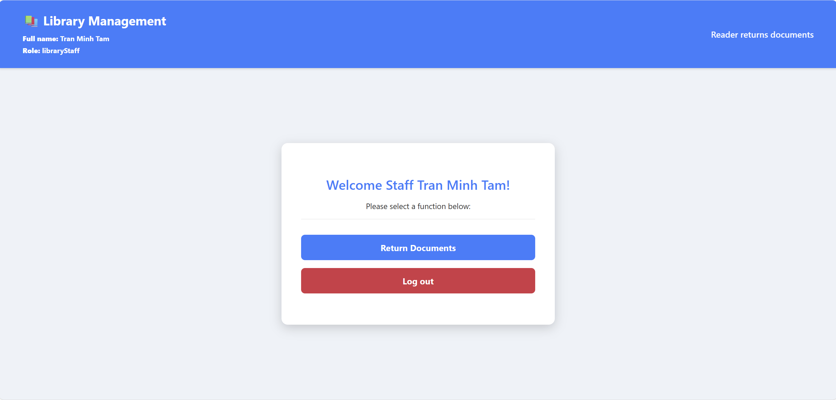
- The staff clicks Return Documents → The system displays the Search Reader interface, allowing the staff to search for a reader by their reader ID. If no ID is entered, the system will display an error. After entering the ID, the system shows a list of readers that match the search criteria.
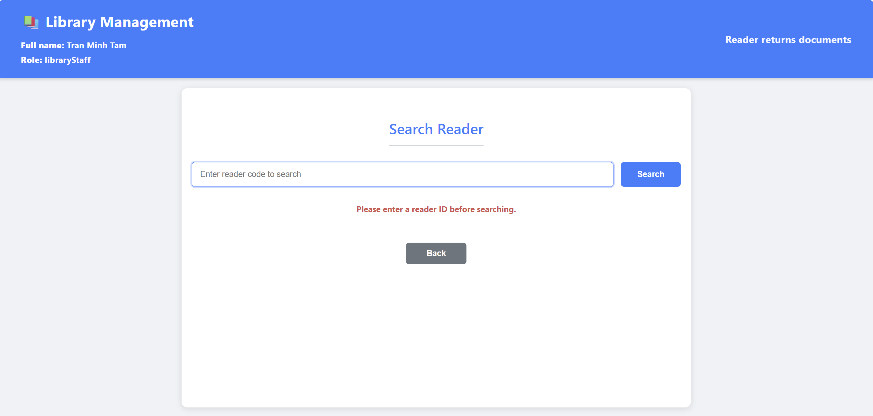
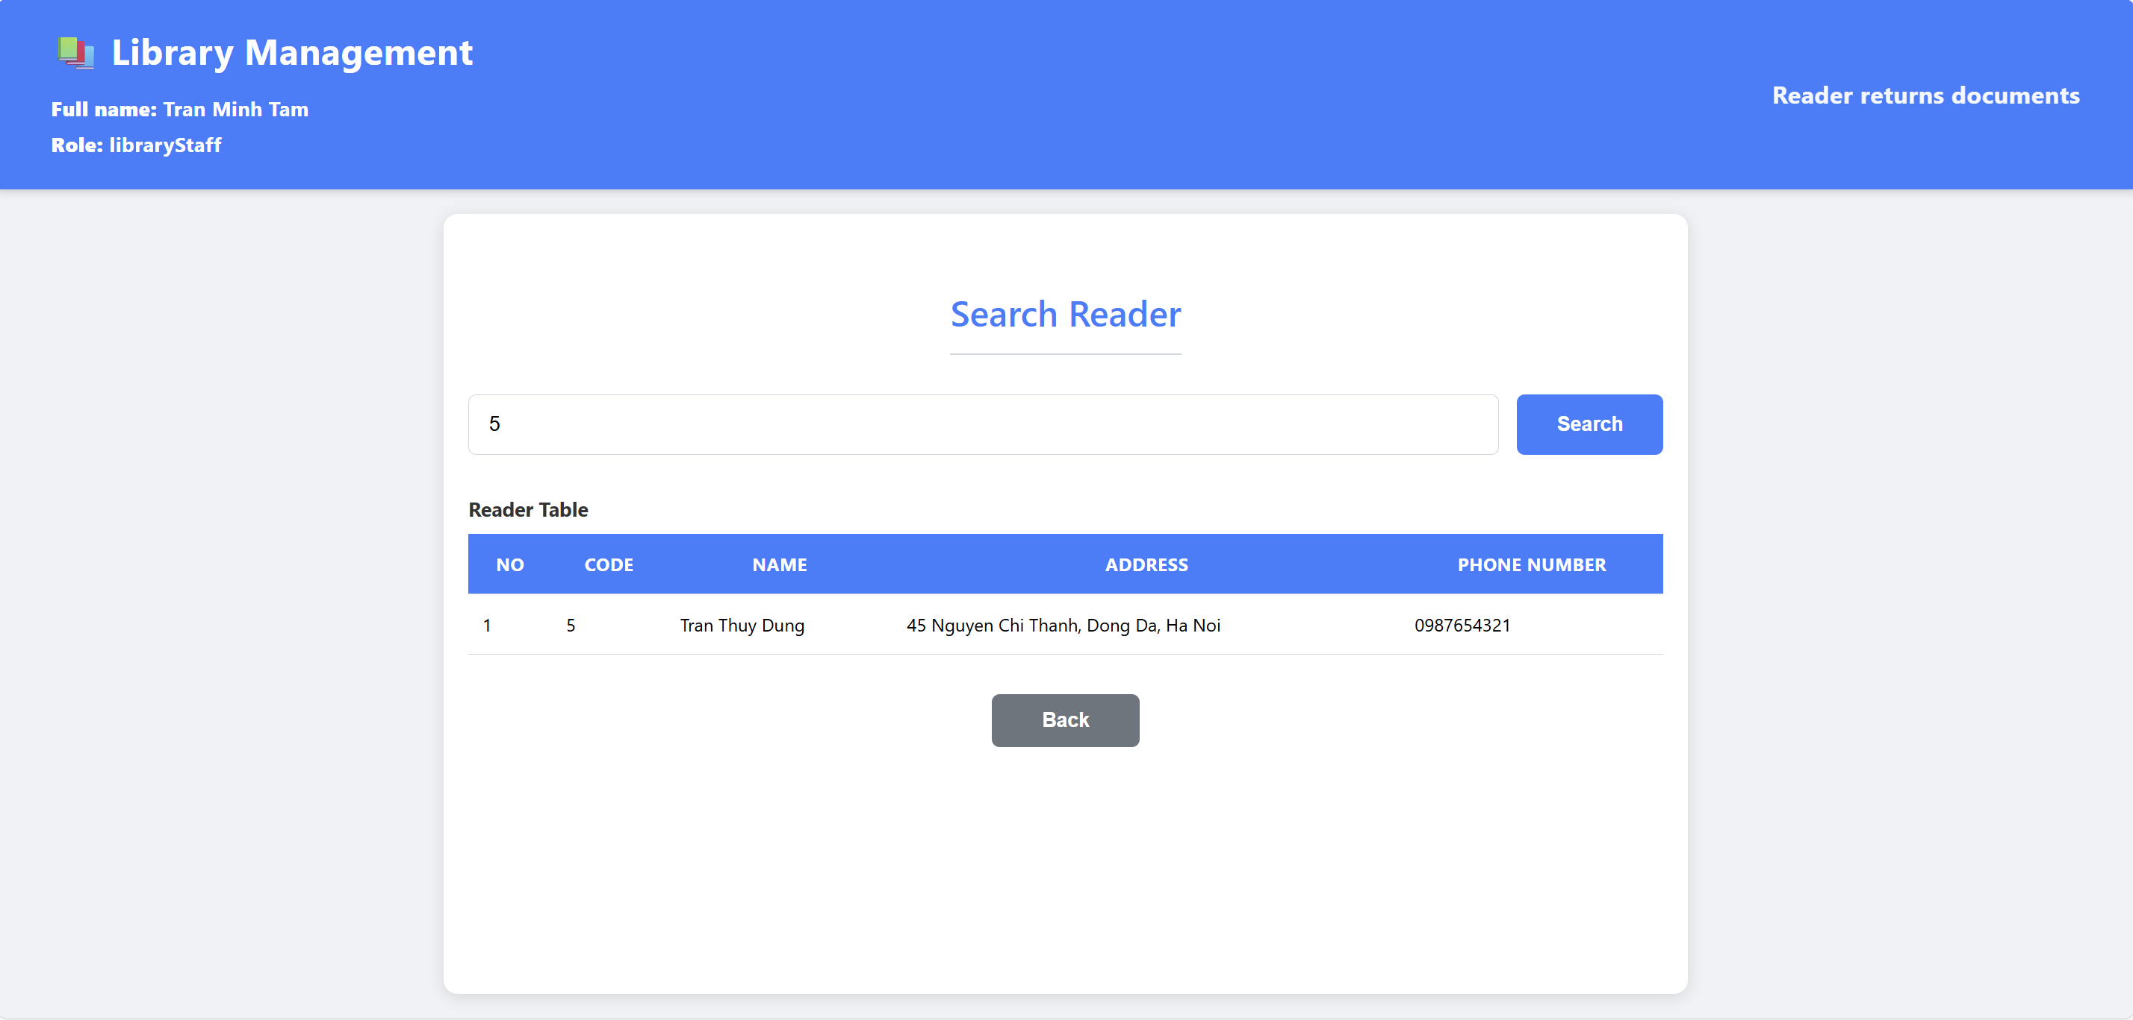
- The staff selects the correct reader by clicking on the corresponding row. The system then displays the list of documents that the reader has borrowed. If no document is chosen after click Next, the system will display an error.
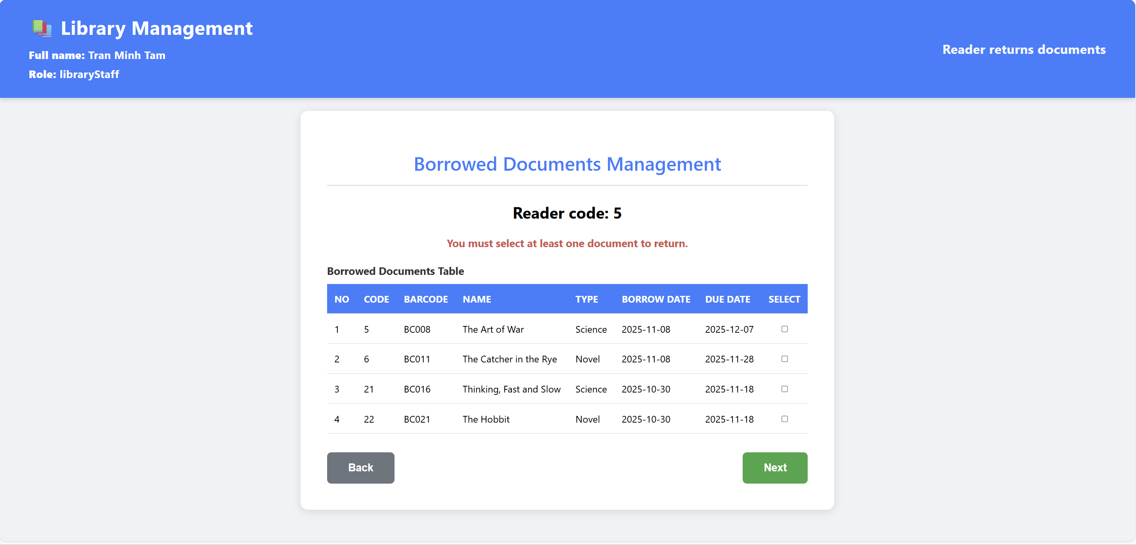
- The staff ticks the checkboxes for the items being returned and clicks the Next button. The system will display an interface to search for fines associated with damaged or lost documents.
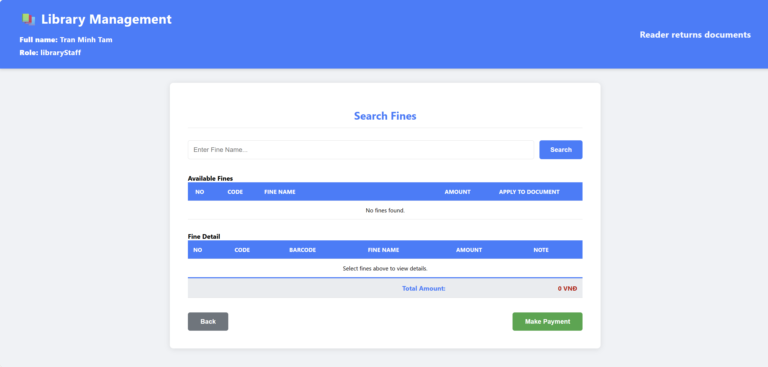
- The staff then selects the appropriate type of fine for each document and clicks Make Payment. If the documents are intact, the staff can click Make Payment to skip the fine.
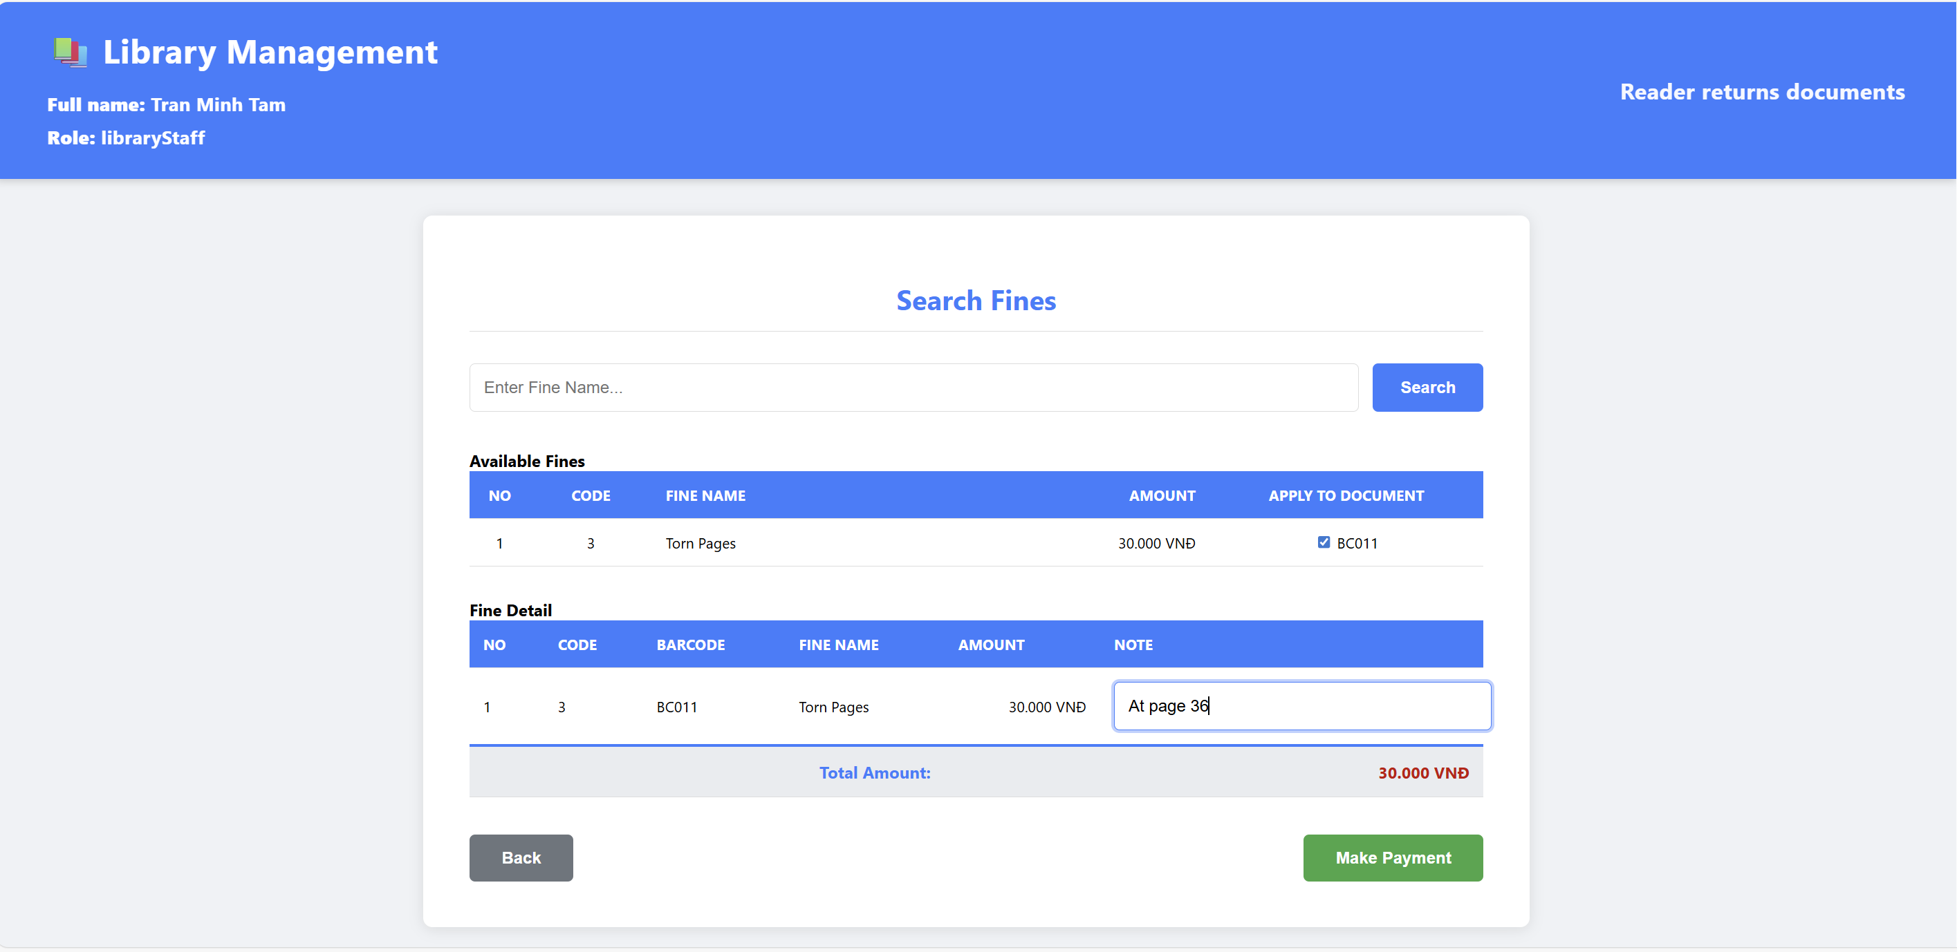
- After clicking Make Payment, the system generates a confirm return UI, including customer information, details of the returned documents, and any fines for damages or late returns.
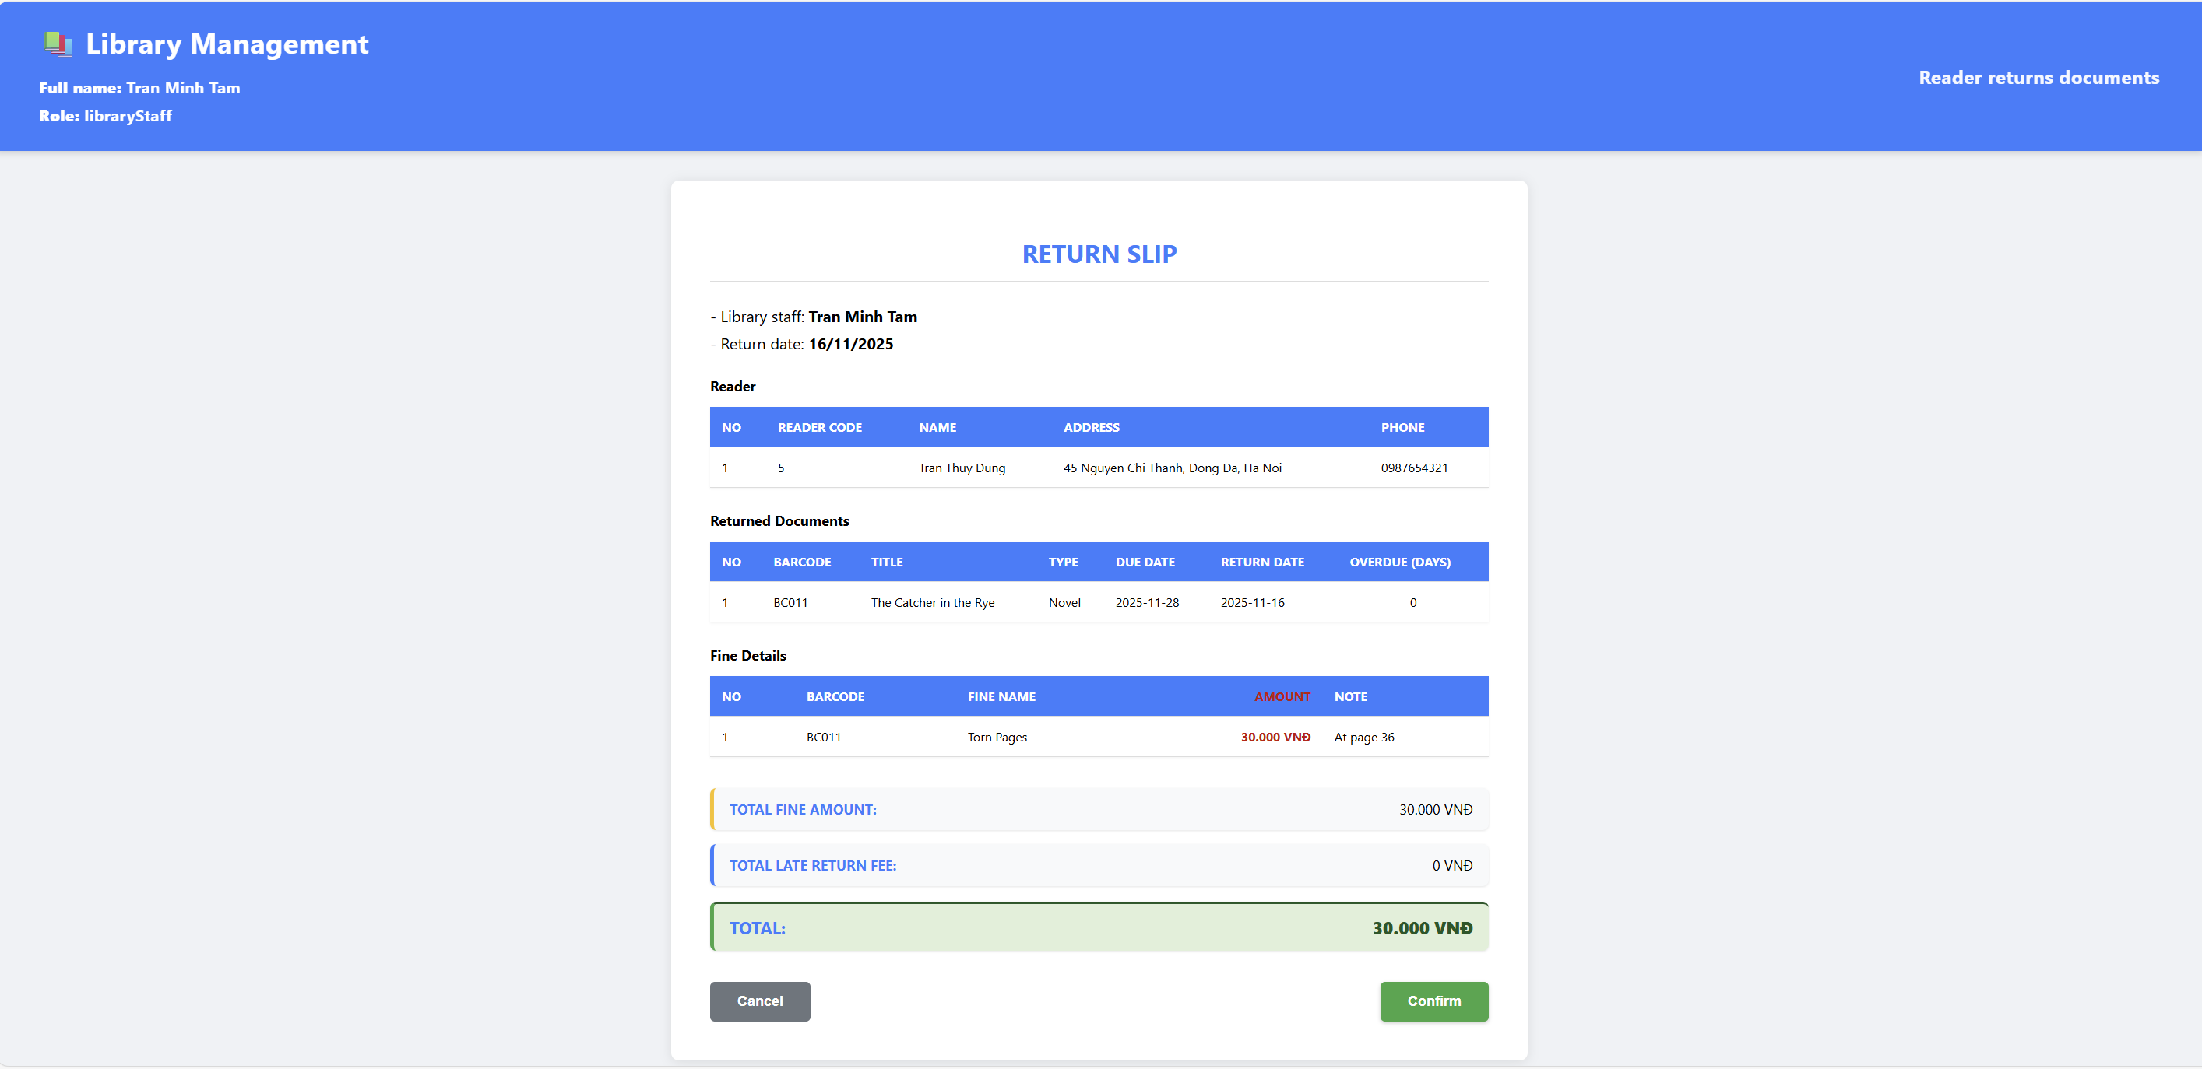
- The staff clicks Confirm, and the system saves the information into the database and displays a success message.
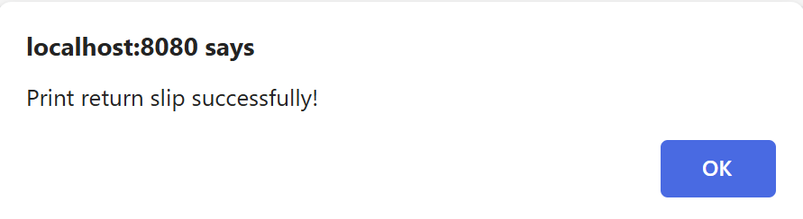

2. CODING STRUCTURE
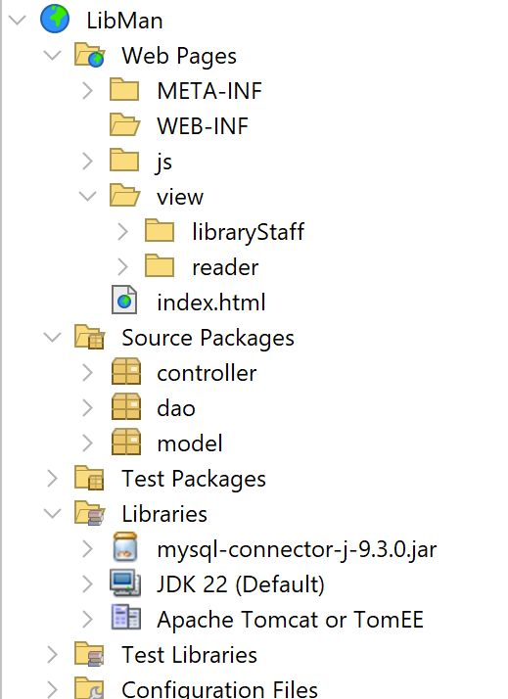

3. SOURCE CODE
AlgebraxCalculus/Tran-Thanh-Thuy-LibraryManagement: BTL môn PTTK: Module Đăng ký bạn đọc và Trả sách

